

MILESTONE ASSESSMENT-2

Project Documentation

KADIRE AKSHARA

**Problem Statement:**

create an end to end CI/CD pipeline in aws platform using jenkins as the orchestration tool,Github as scm ,maven as the build tool,deploy in a docker instance and create a docker imagr,store the docker image in ECR,achieve Kubernetes deployment using ECR image.Build sample java web app using maven.

**Approach:**

**Requirements :**

* CI/CD pipeline System
* Git - local version control system.
* GitHub - As Distributed version control system.
* Jenkins - Continuous Integration tool.
* Maven - As a Build Tool.
* Ansible - Configuration Management & Deployment tool.
* Docker -Containerization
* Kubernetes - As Container Management Tool

**Step-1:**

* Setup CI/CD with GitHub, Jenkins, Maven & Tomcat.
* Setup Jenkins
* Setup & Configure Maven, Git.
* Setup Tomcat Server.
* Integrating GitHub, Maven, Tomcat Server with Jenkins
* Create a CI and CD Job.
* Test the Deployment

**Step-2:**

* Setup CI/CD with GitHub, Jenkins, Maven & Docker.
* Setting up the docker Environment.
* Write DockerFile.
* Create an Image.
* Integrate Docker Host with Jenkins.
* Create CI/CD Job on Jenkins to build and deploy on container.

**Step-3:**

* Build and Deploy on Container.
* CI/CD with GitHub, Jenkins, Maven, Ansible & Kubernetes.
* Setting up the Kubernetes (EKS).
* Write pod service and deployment manifest file.
* Integrate Kubernetes with Ansible.
* Ansible playbook to create deployment & service.
* CI/CD Job to build code on Ansible & Deploy it on Kubernetes.

**Step-4:**

* Deploy artifacts on the kubernetes

🡪Created two ec2 instances as Jenkins server and git server

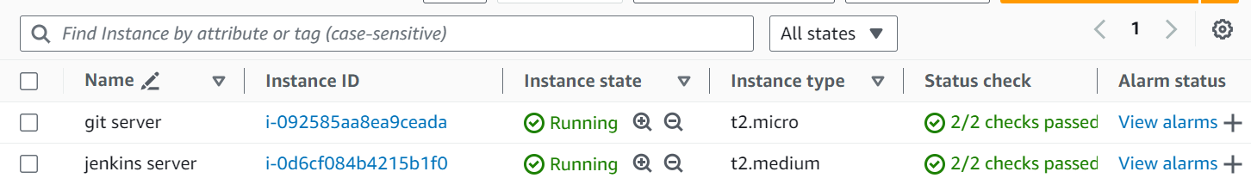

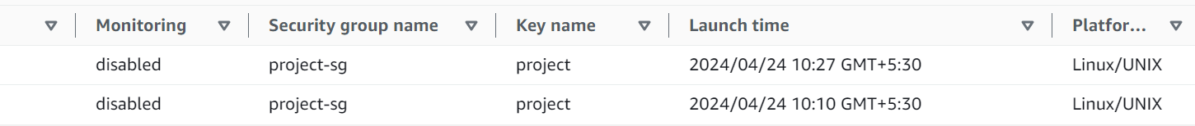

🡪Install git on Jenkins server and git server also install Jenkins on git server

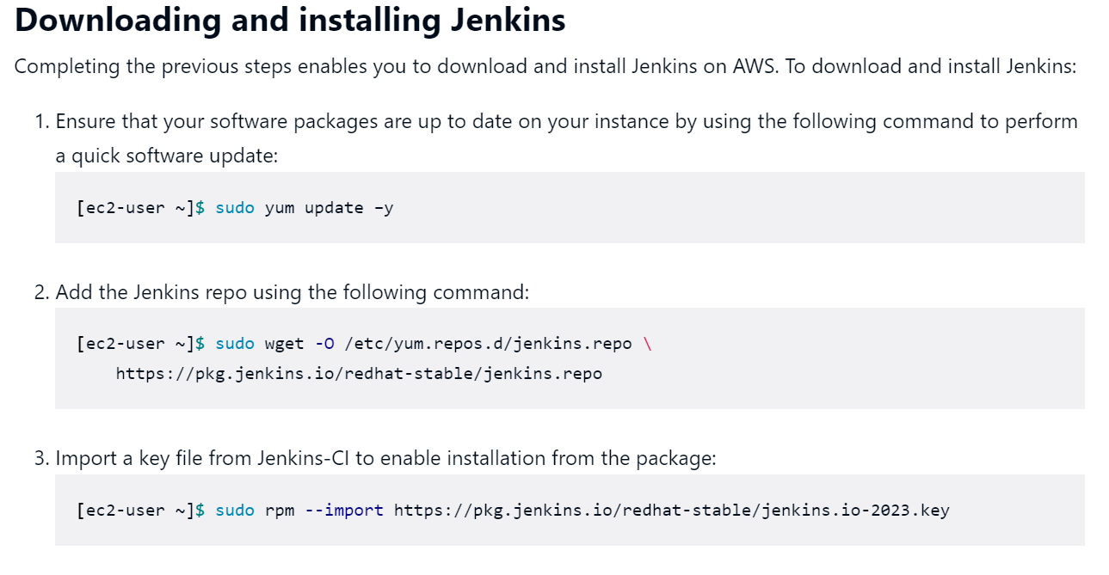

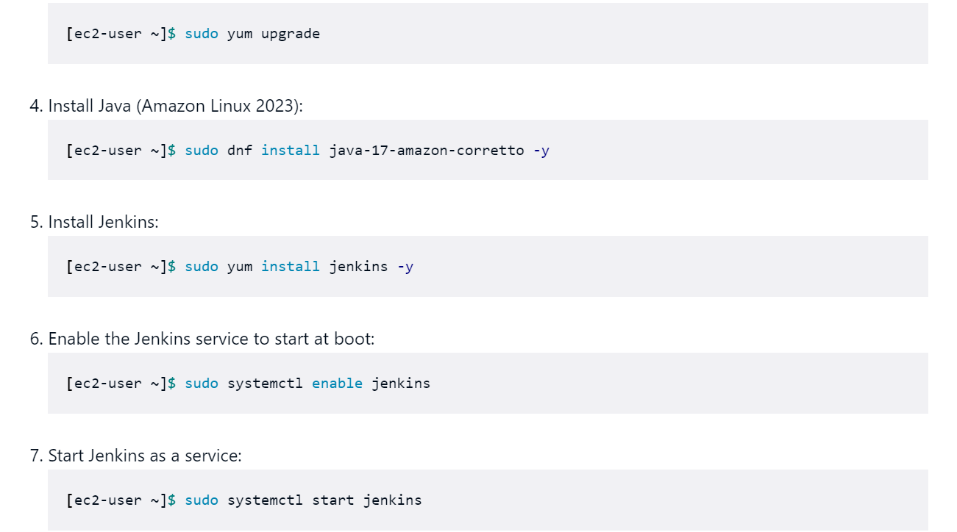

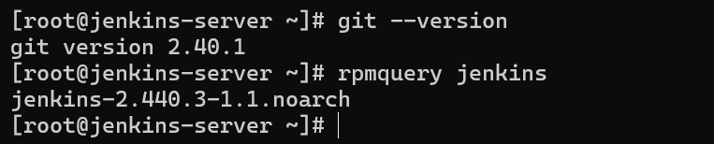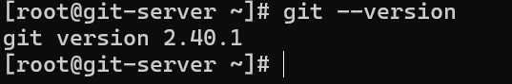

🡪Configure ssh and allow permission in Jenkins and git servers

🡪Now we need to integrate git server with github by generating a SSH key and adding it to the SSH keys in the github.

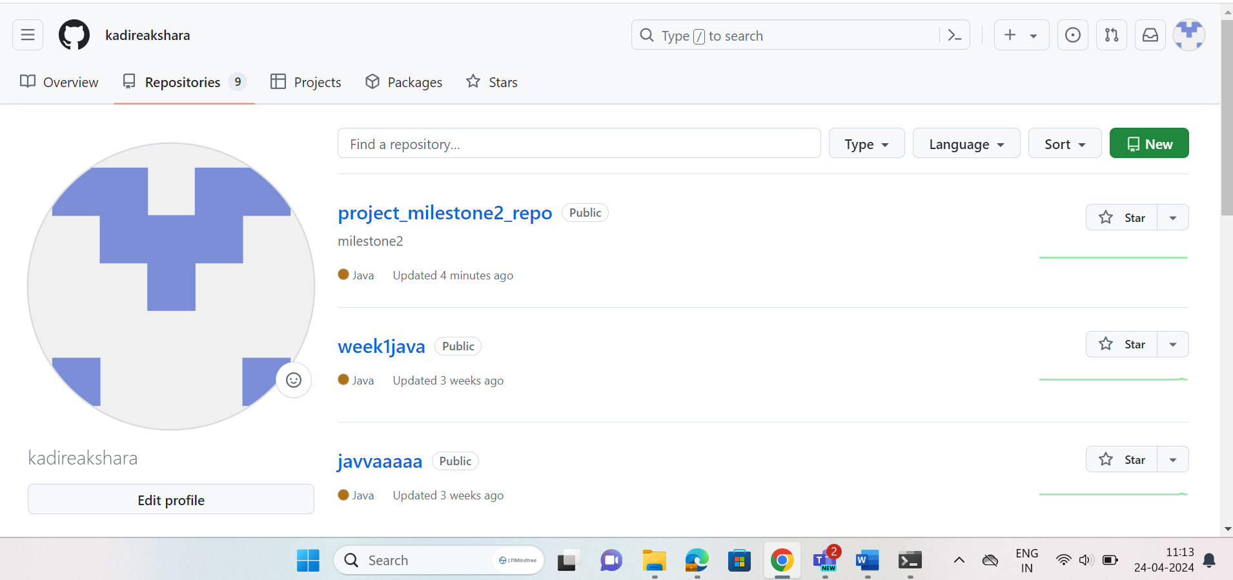

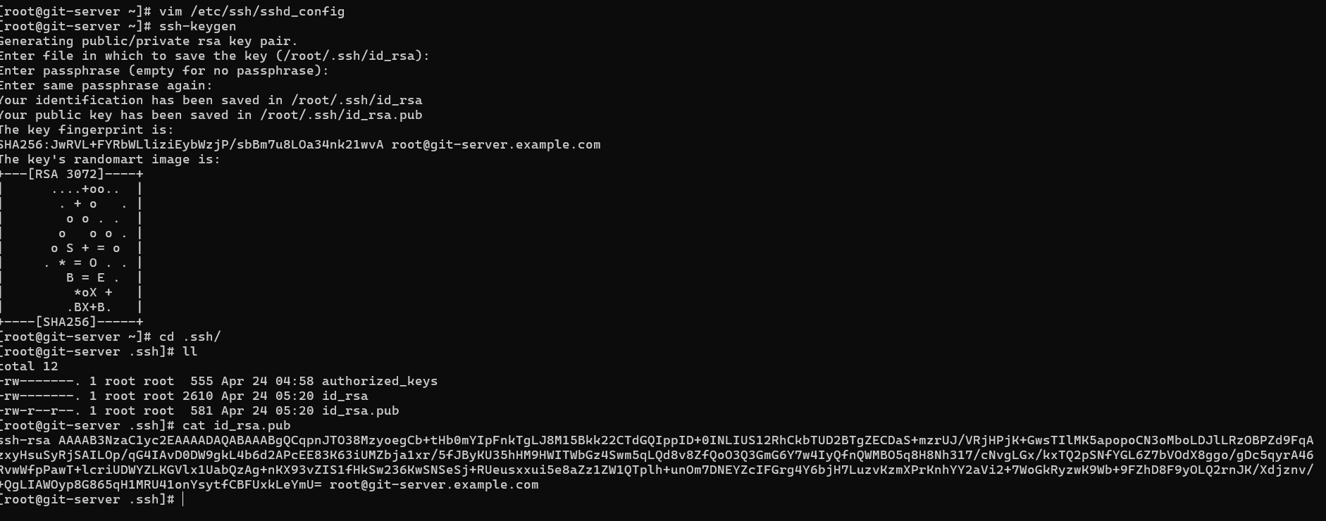

🡪Now we have successfully integrated the git server with github. Now create an repository in the github and try to push a file from git server to ensure integration.

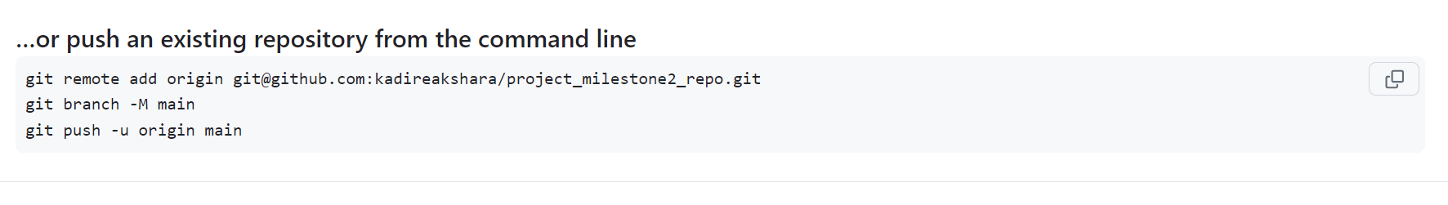

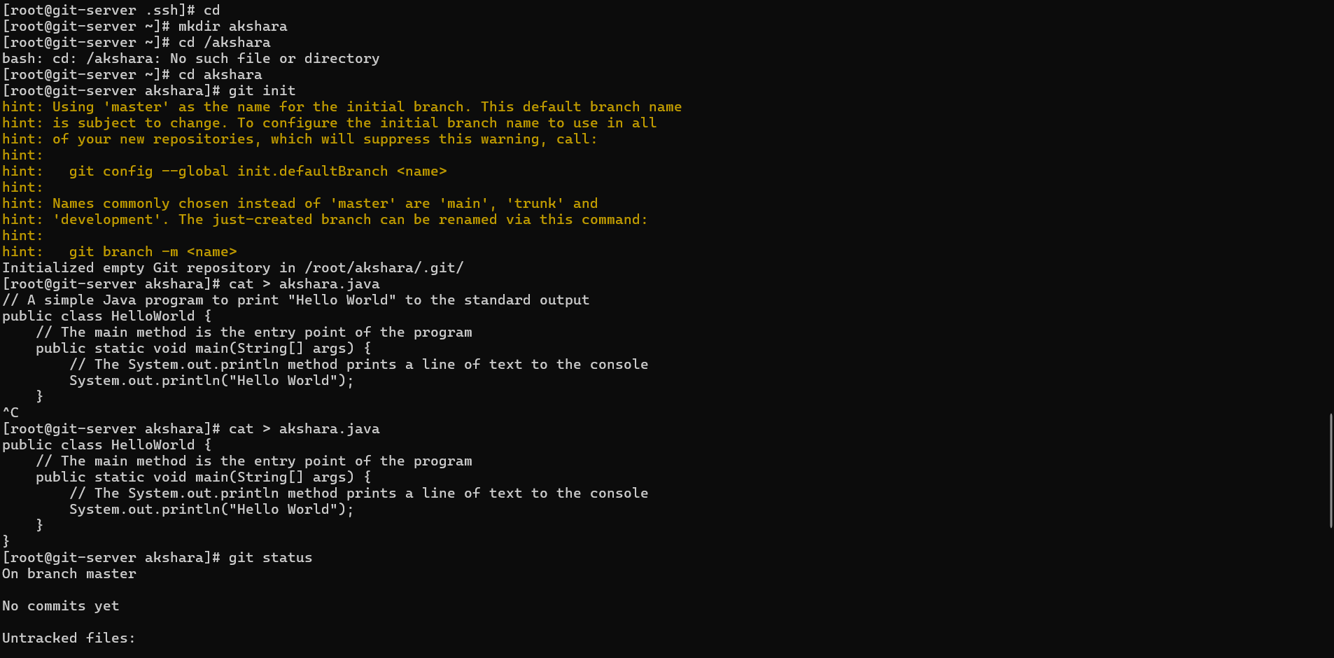

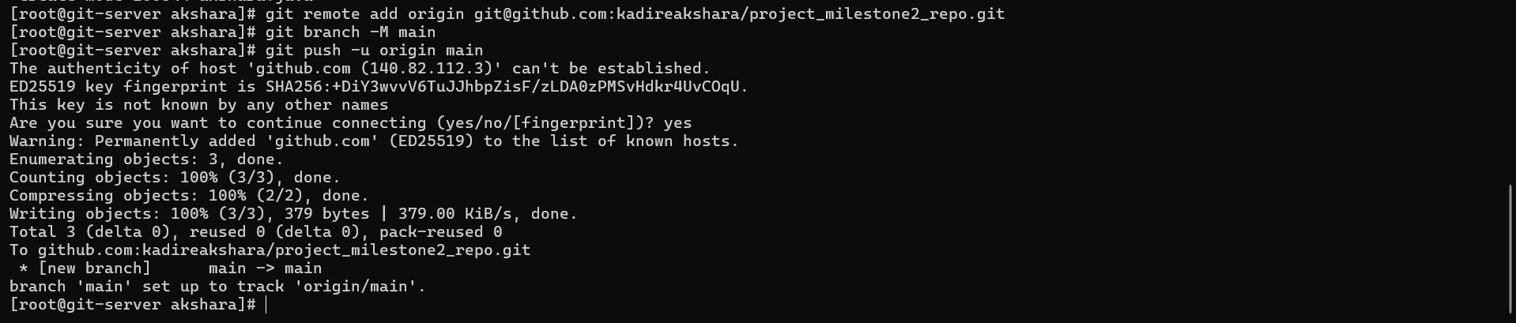

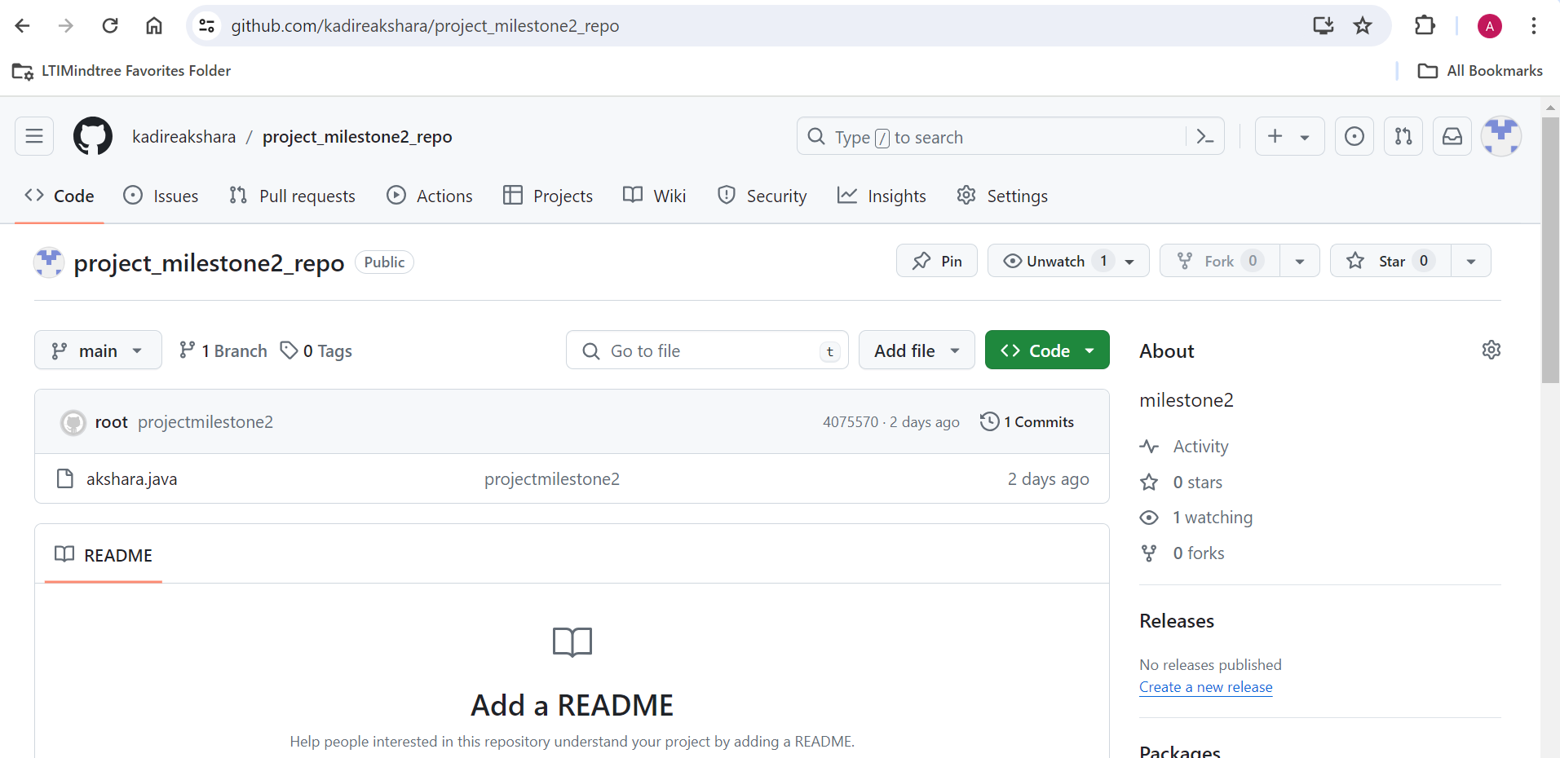

🡪Now in the same way coming to the jenkins server install GIT and Jenkins packages accordingly as shown below.Make sure java is also installed with them.After installing

do update and start the jenkins in the server

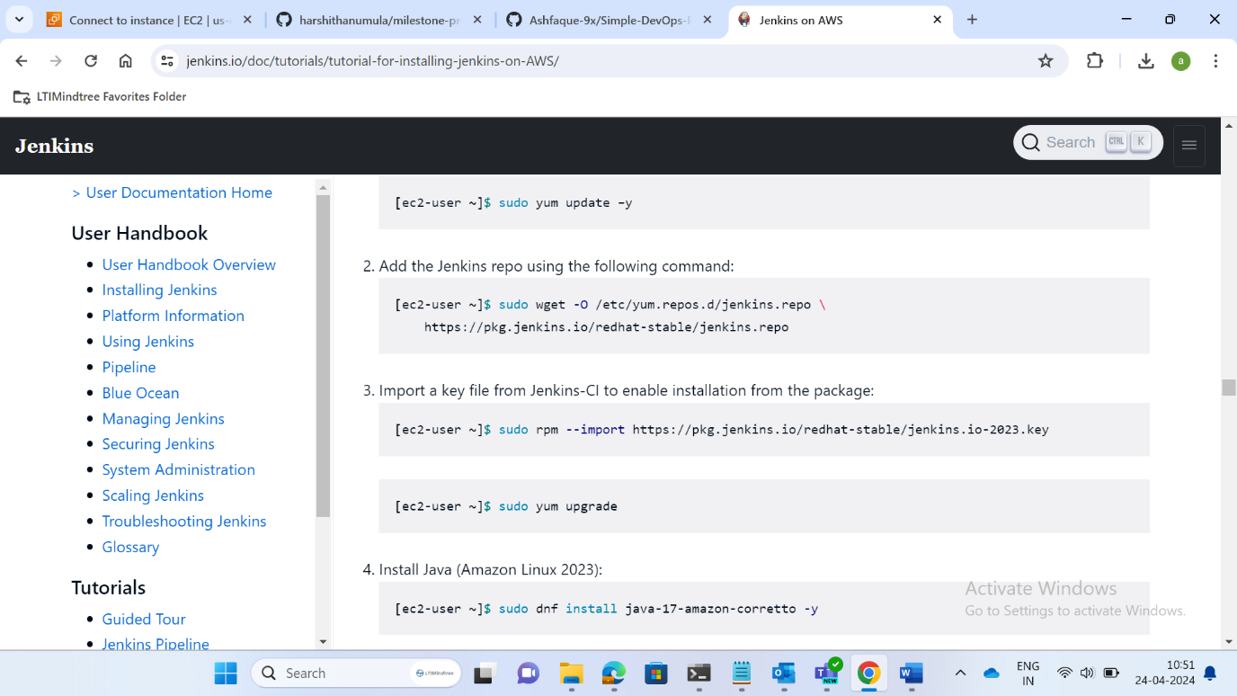

🡪Now go to the jenkins instance and copy the public ip of it and paste it in the other windows with :8080, we get the server as shown below.Now copy the path link and paste in the SSH command promt (cmd) terminal to the administrator password.

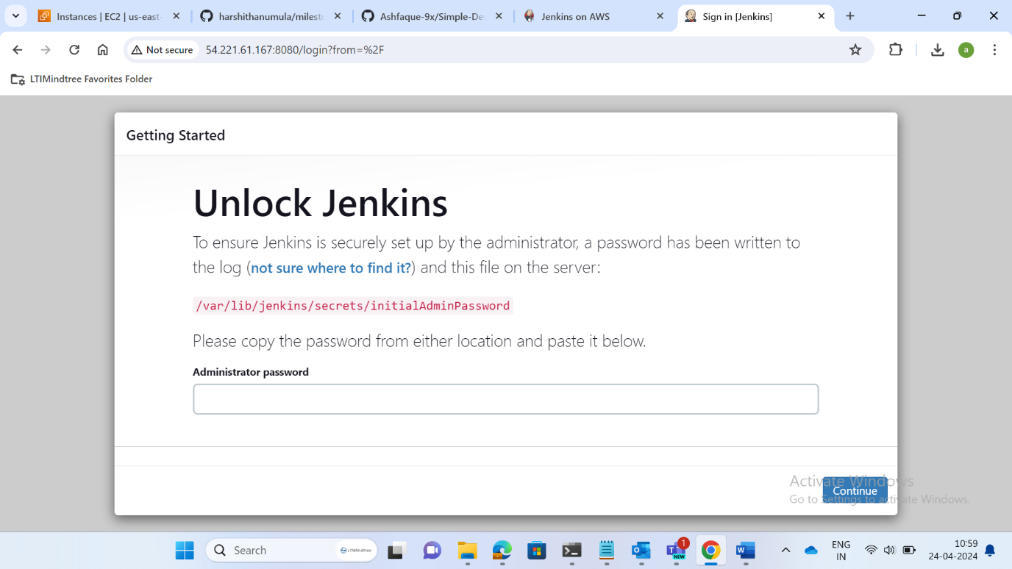

🡪Create the admin user for jenkins give the password and email address.

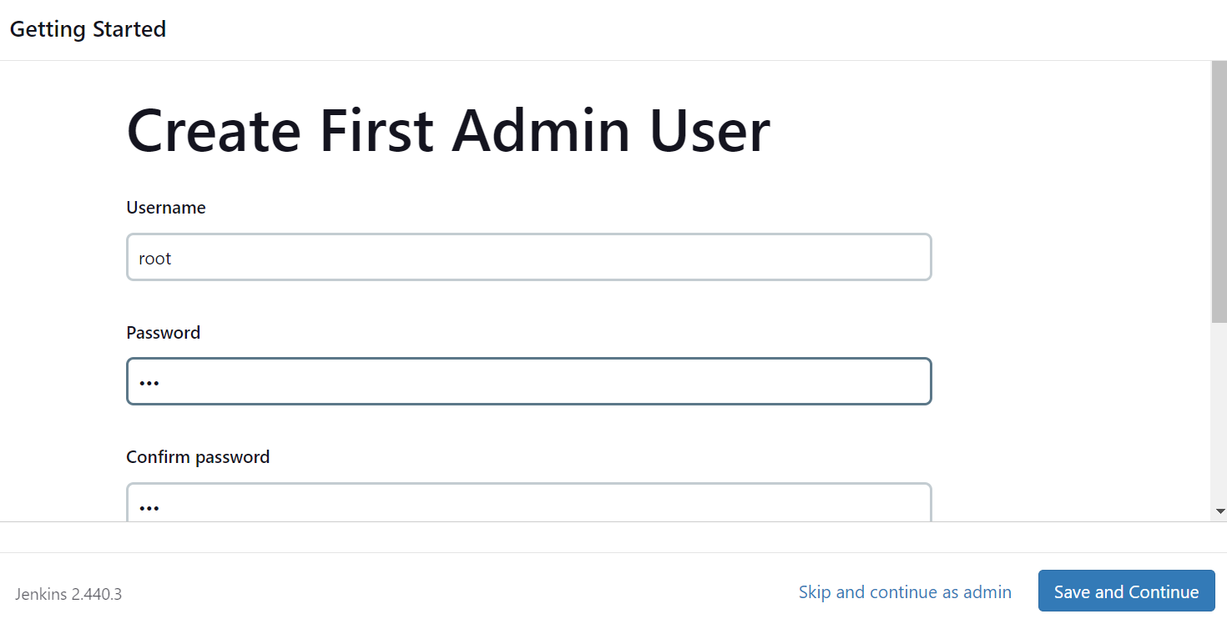

🡪Now install the required plugins as shown below.

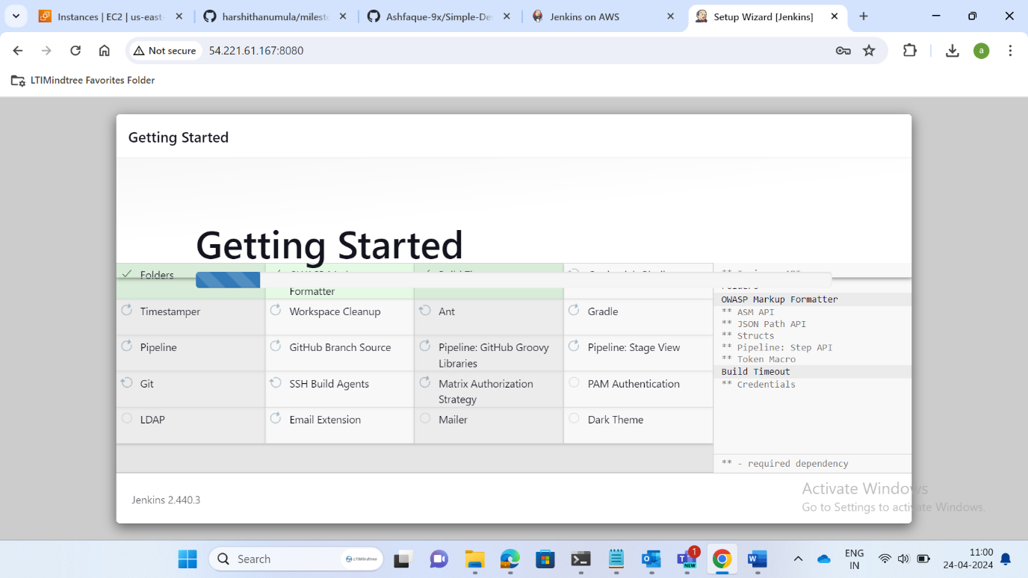

🡪After that we need to integrate the jenkins server with github by creating webhook in created repository as shown below.Copy the link address of the jenkins and paste in the webhook creation.

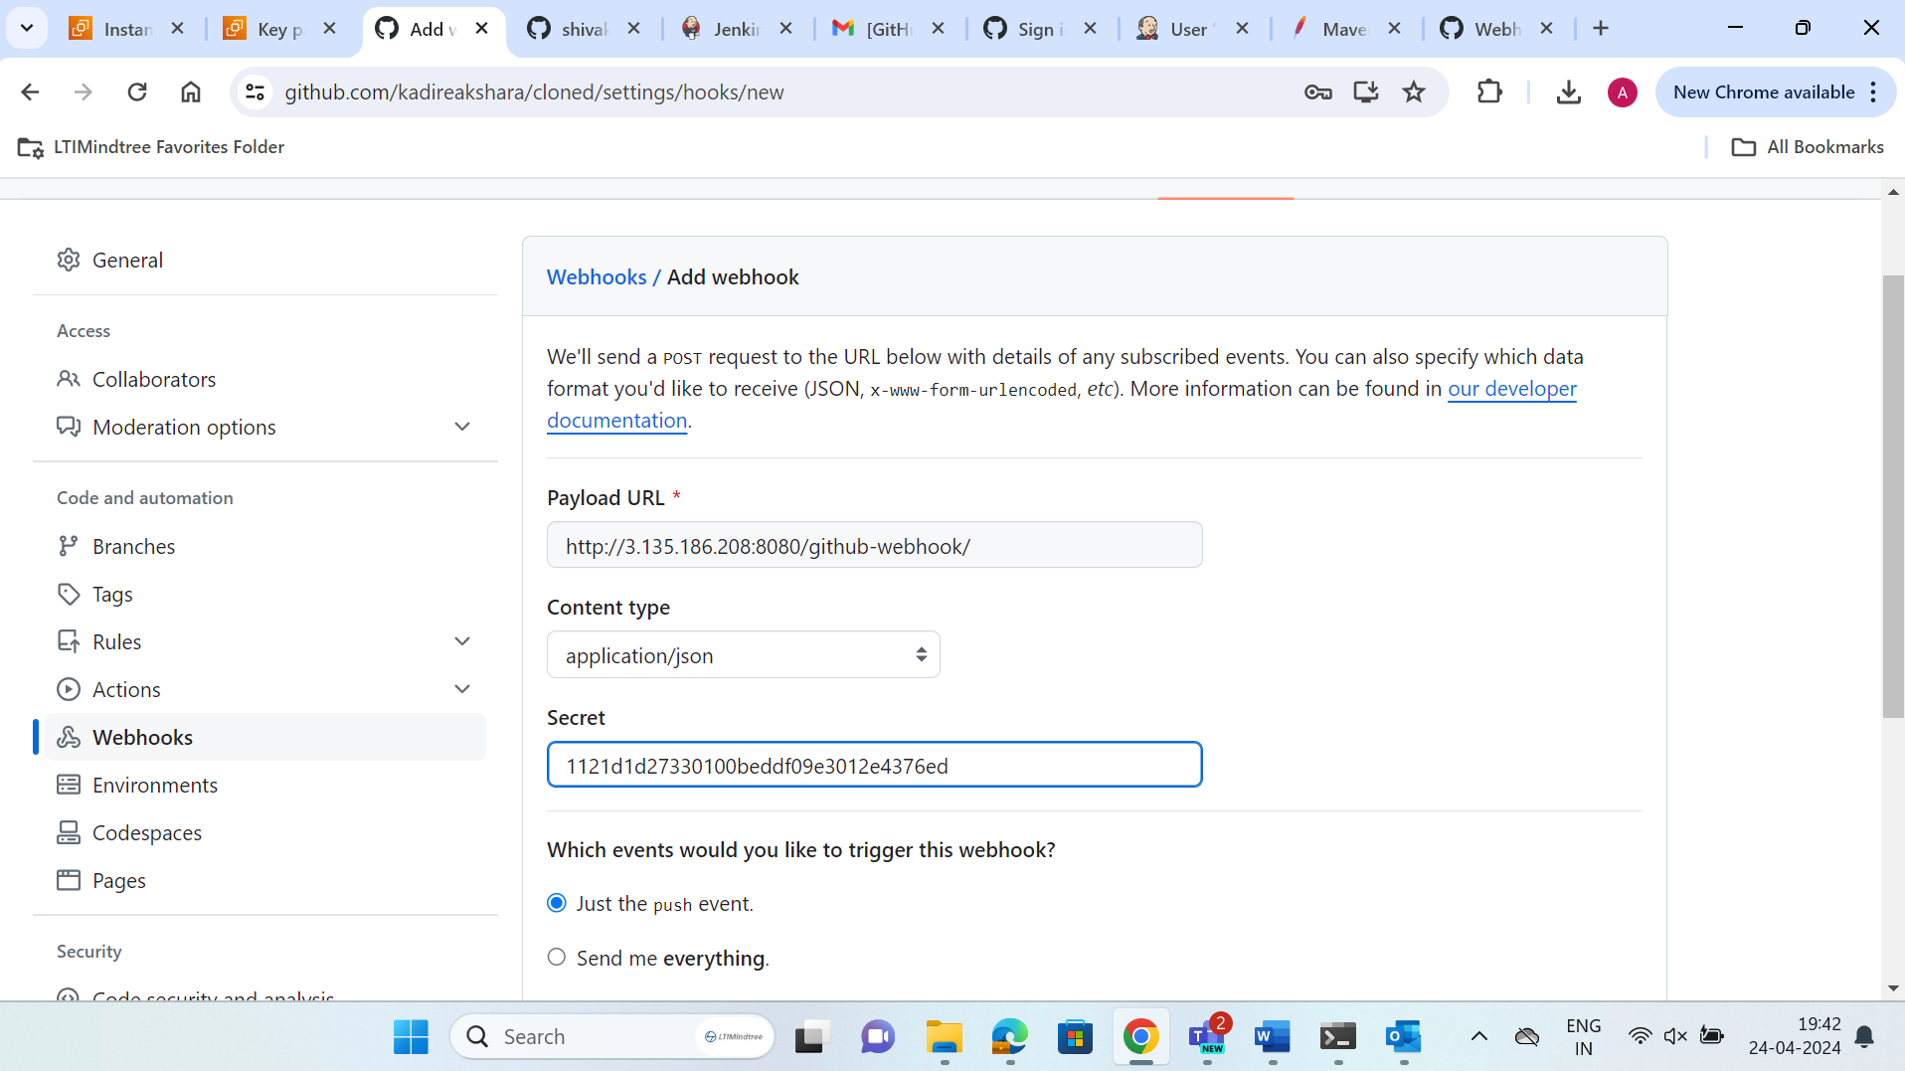

🡪Secret key is taken from the jenkins -> configure -> generate token -> copy

In the jenkins server we need to install maven plugin and also install the maven in the jenkins server.Move the files to the bin and setup environment variables.Next configure maven and java.

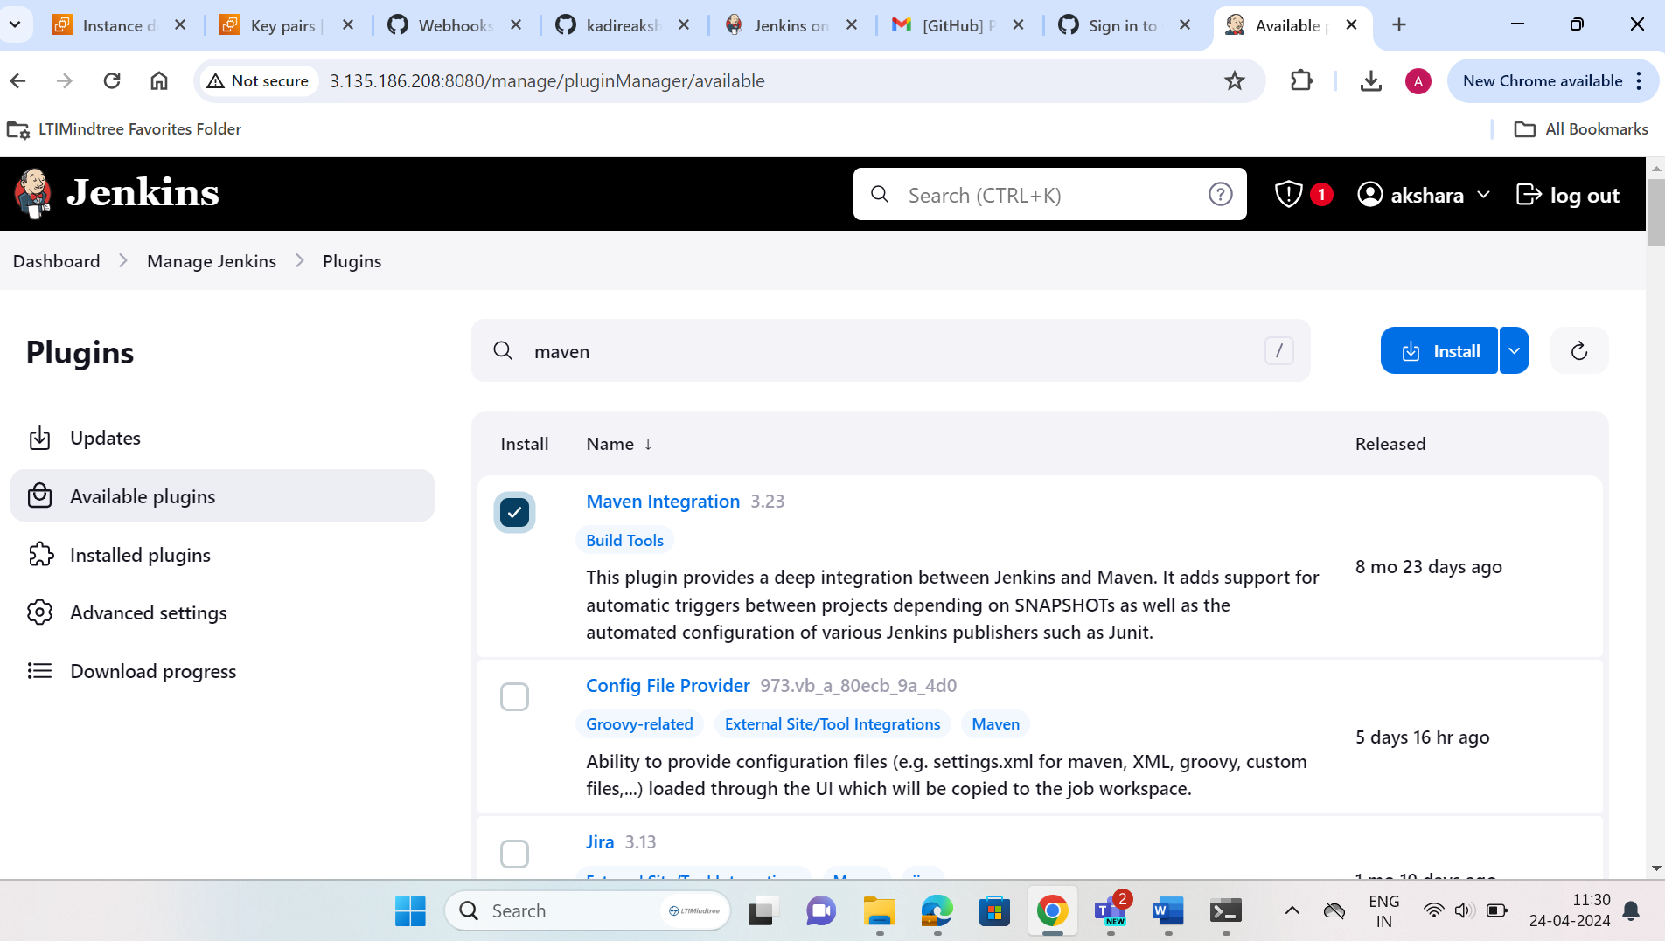

🡪After installing maven in the jenkins server and maven plugin in the jenkins we need to configure the tools (JDK,GIT,MAVEN) with their name and path in the global test configuration.

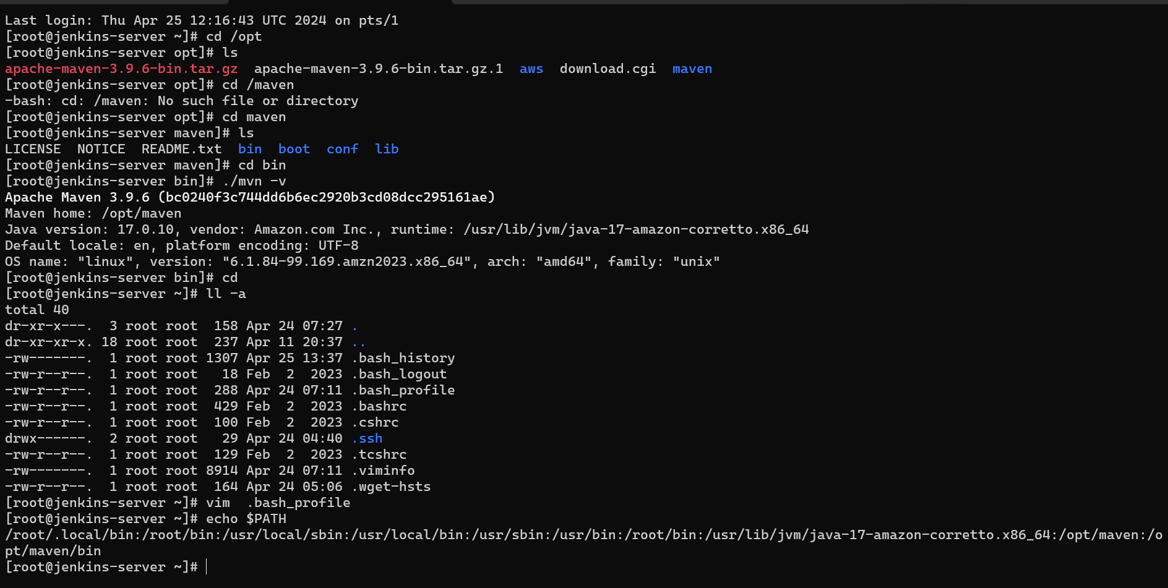

🡪Now build a java project using jenkins by creating new item and then selecting maven project.Give the git repository link and apply.We can observe the below console output showing success.

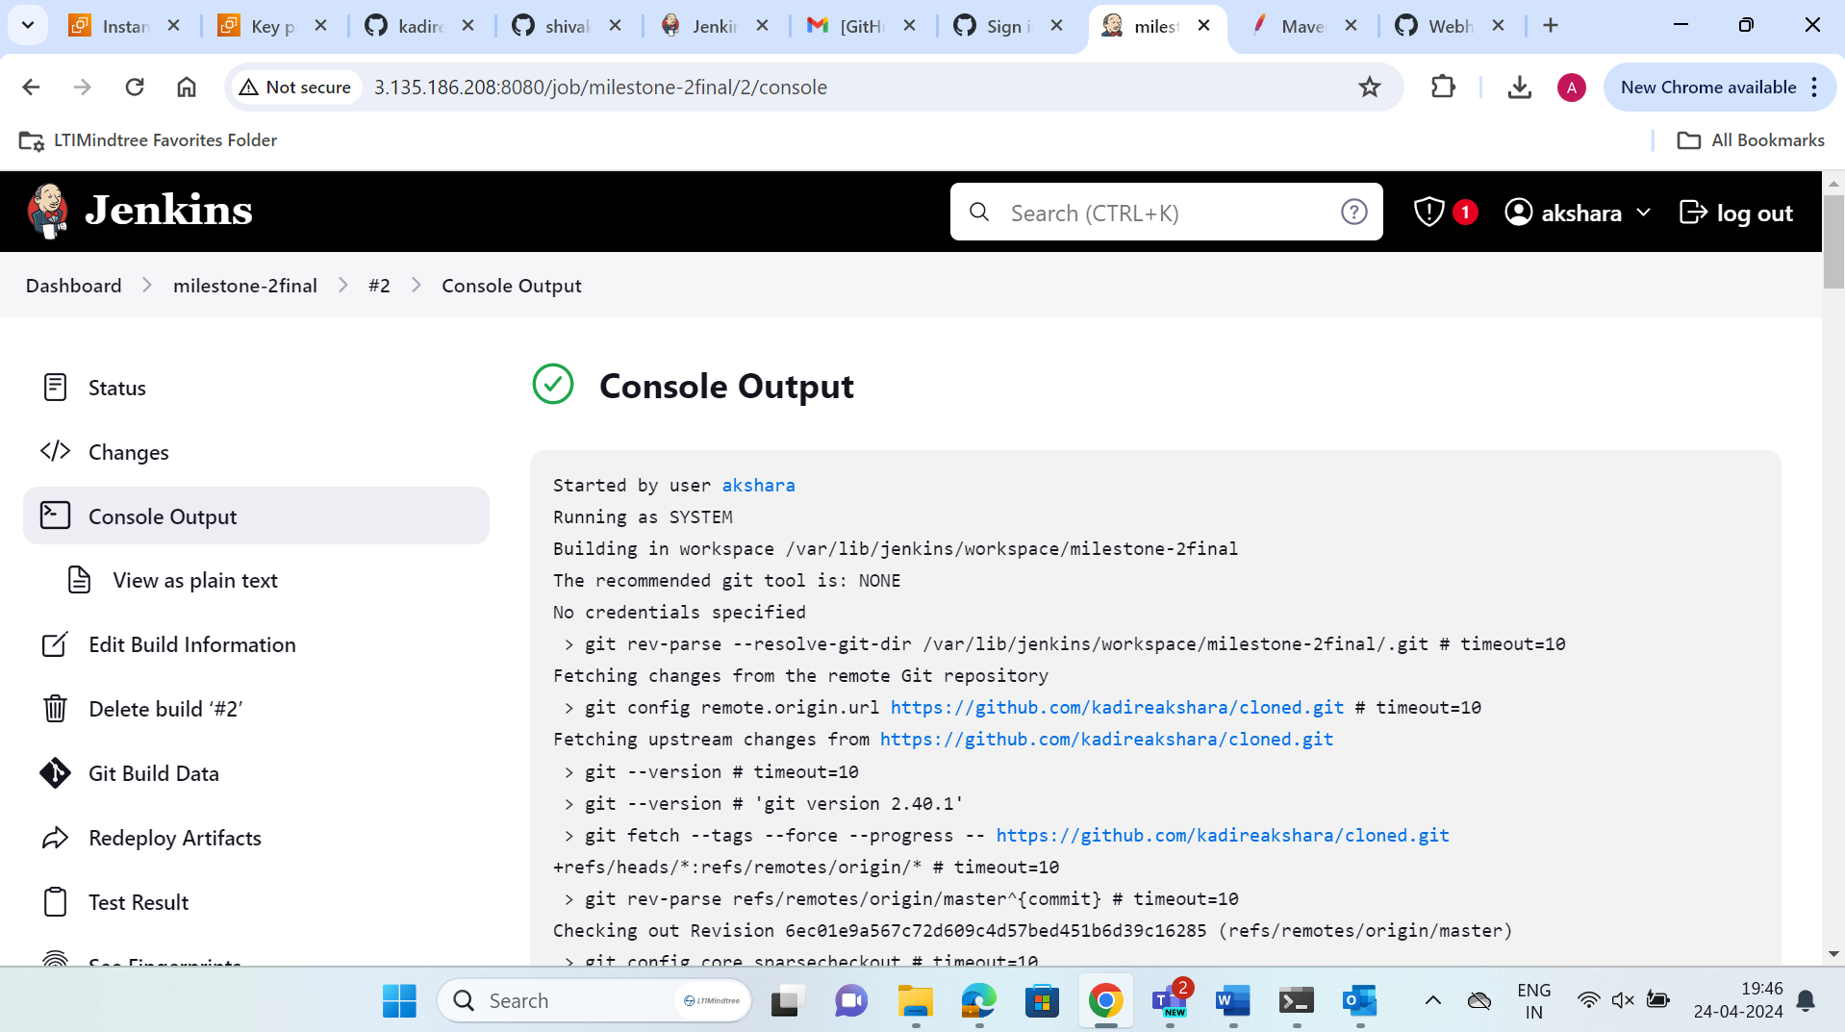

🡪Now after completing this we need to setup a tomcat in git server and integrate it in the CI/CD pipeline.

🡪We should also install java in the tomcat server.The above is the tomcat configuration and we need to start the tomcat server. Now we need to access web user interface on port 8080 we get the server,but when we go in to the UI -> manager app we get http error so for that we need to make some neccesary changes in the context.xml file.Allow access host manager in the context file in /webapps/manager/META-INF/context.xml and add tomcat roles in tomcat-users.xml accordingly.

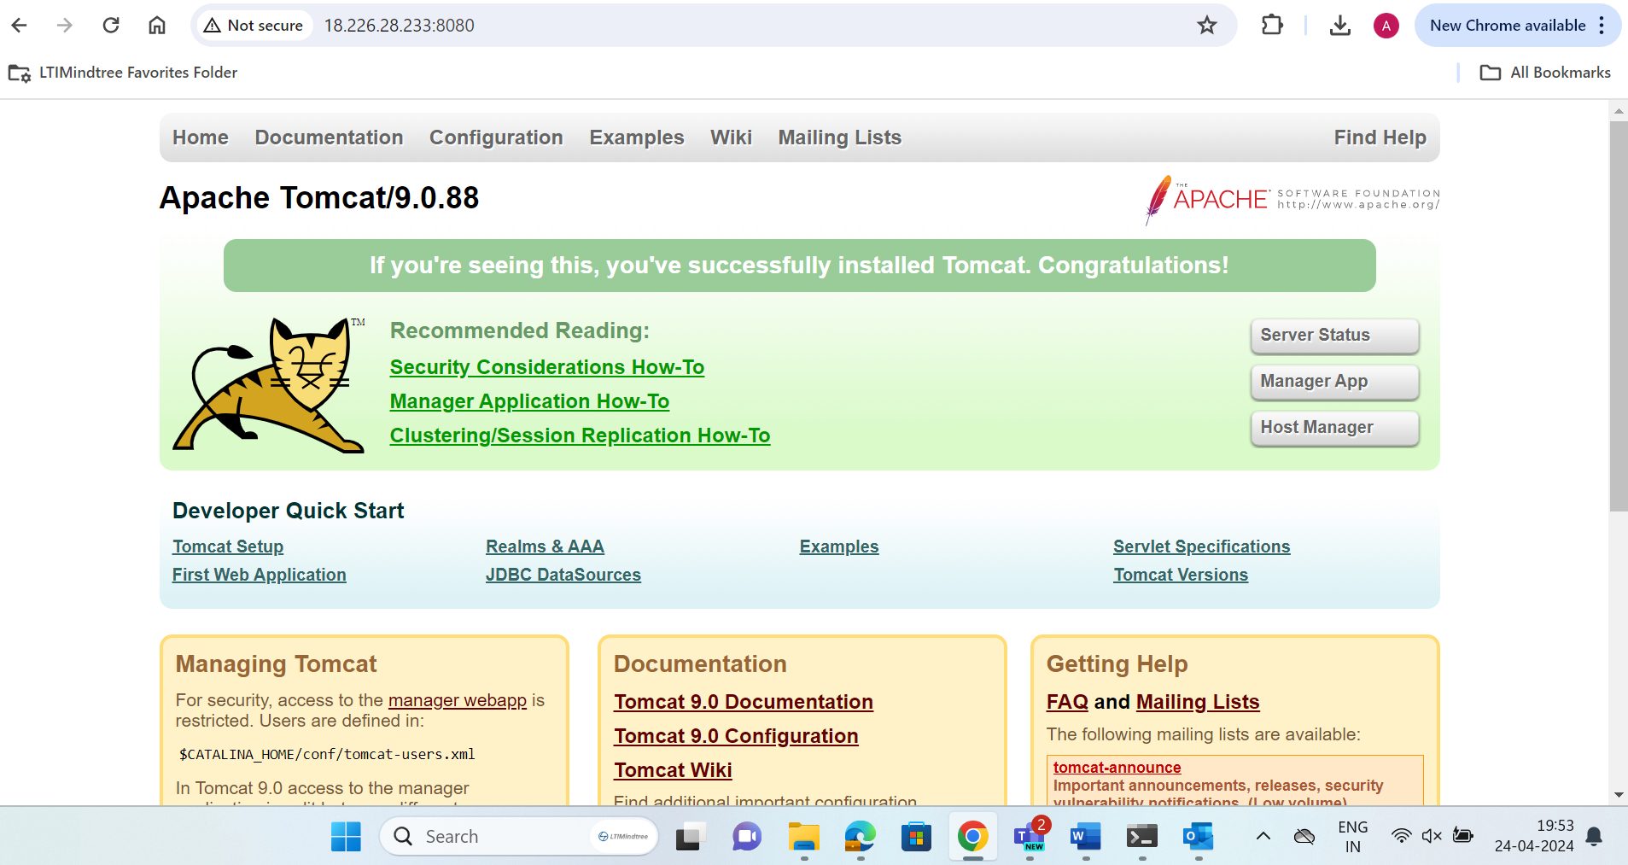

🡪Go to jenkins server and install the deploy to container plugin and build maven accordingly we can now get the UI after going into the manage app as shown below.

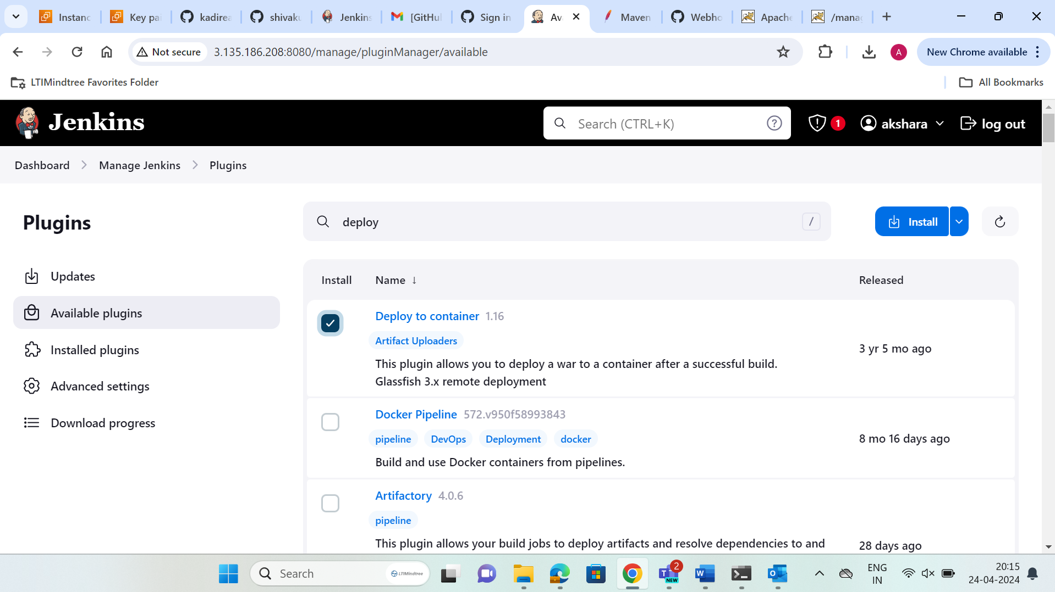

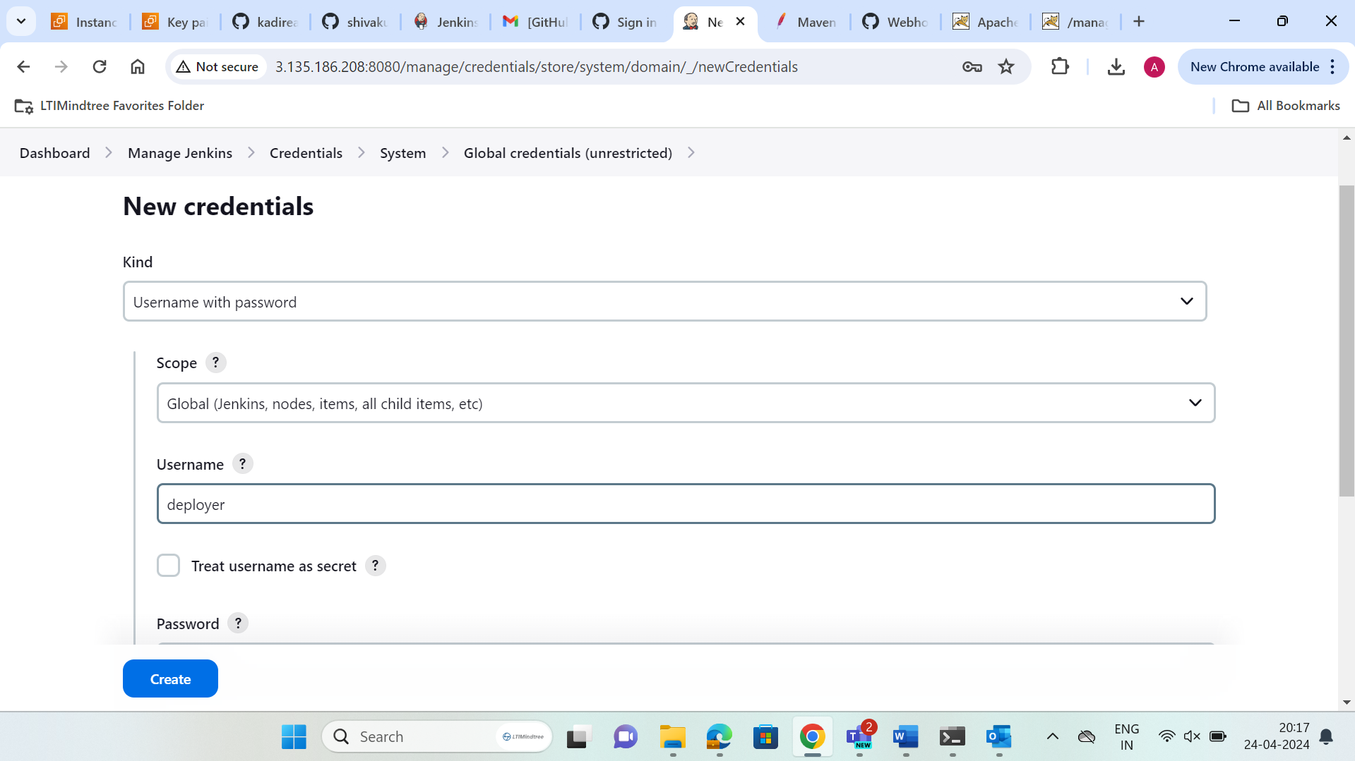

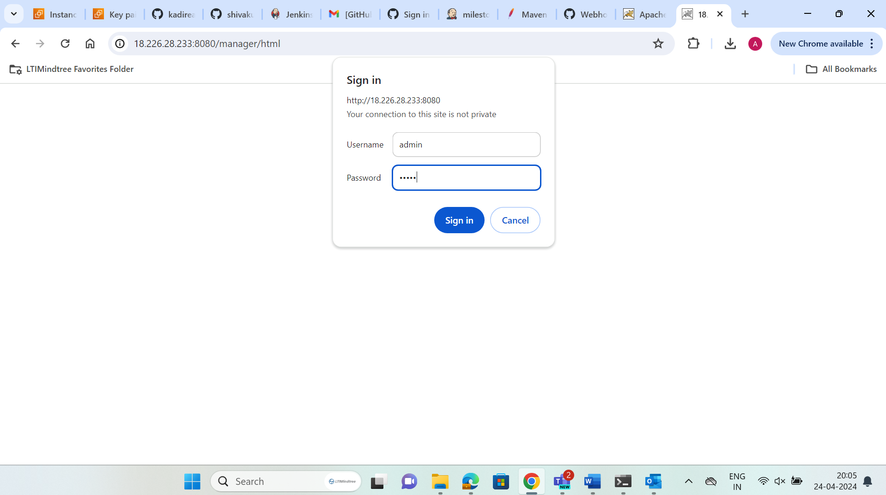

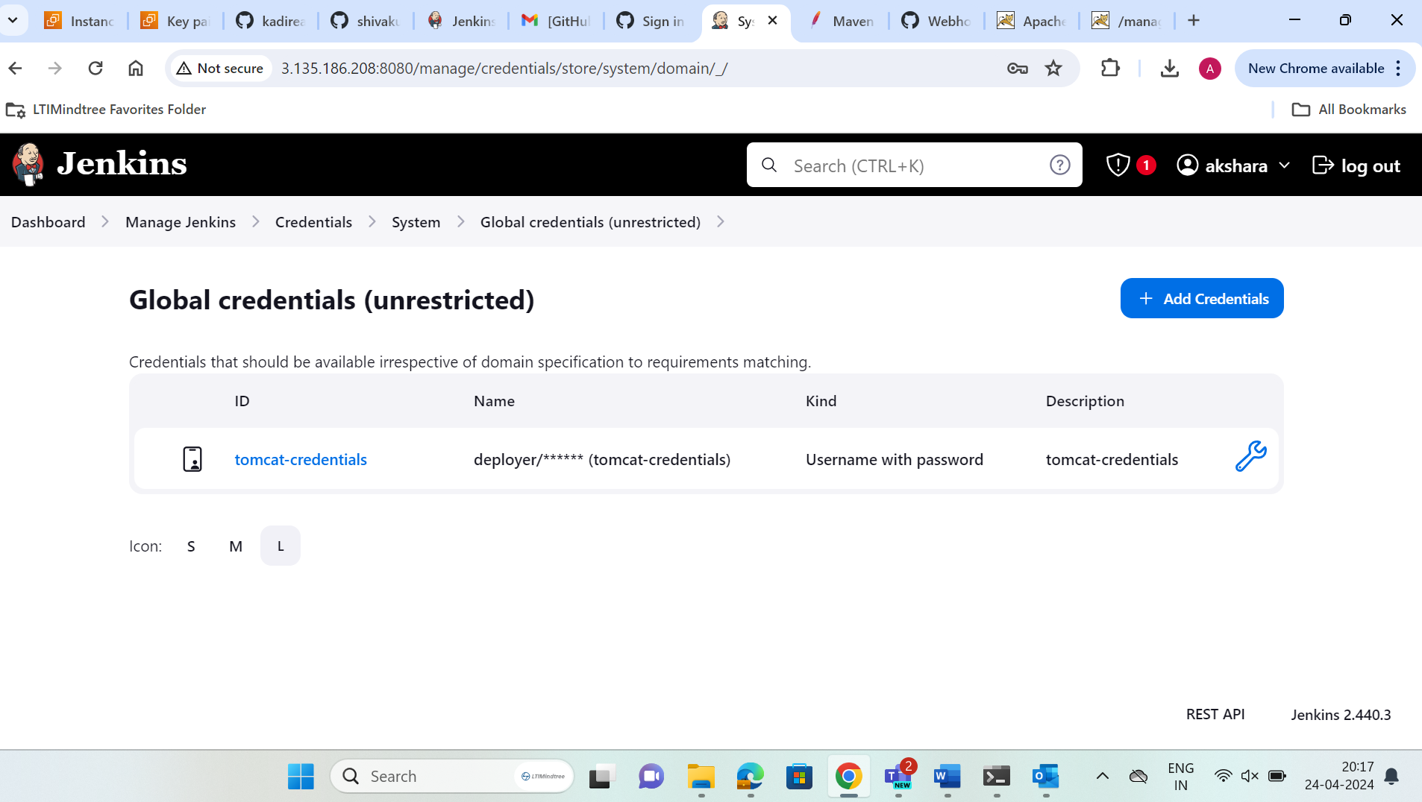

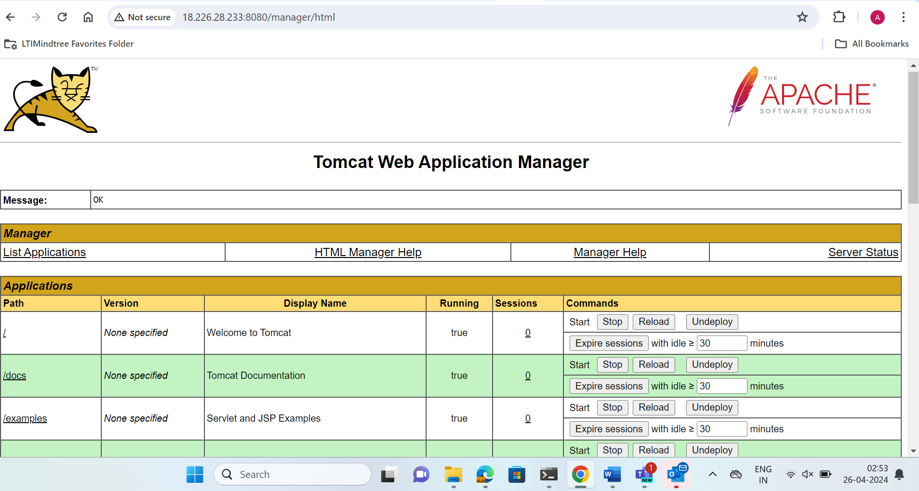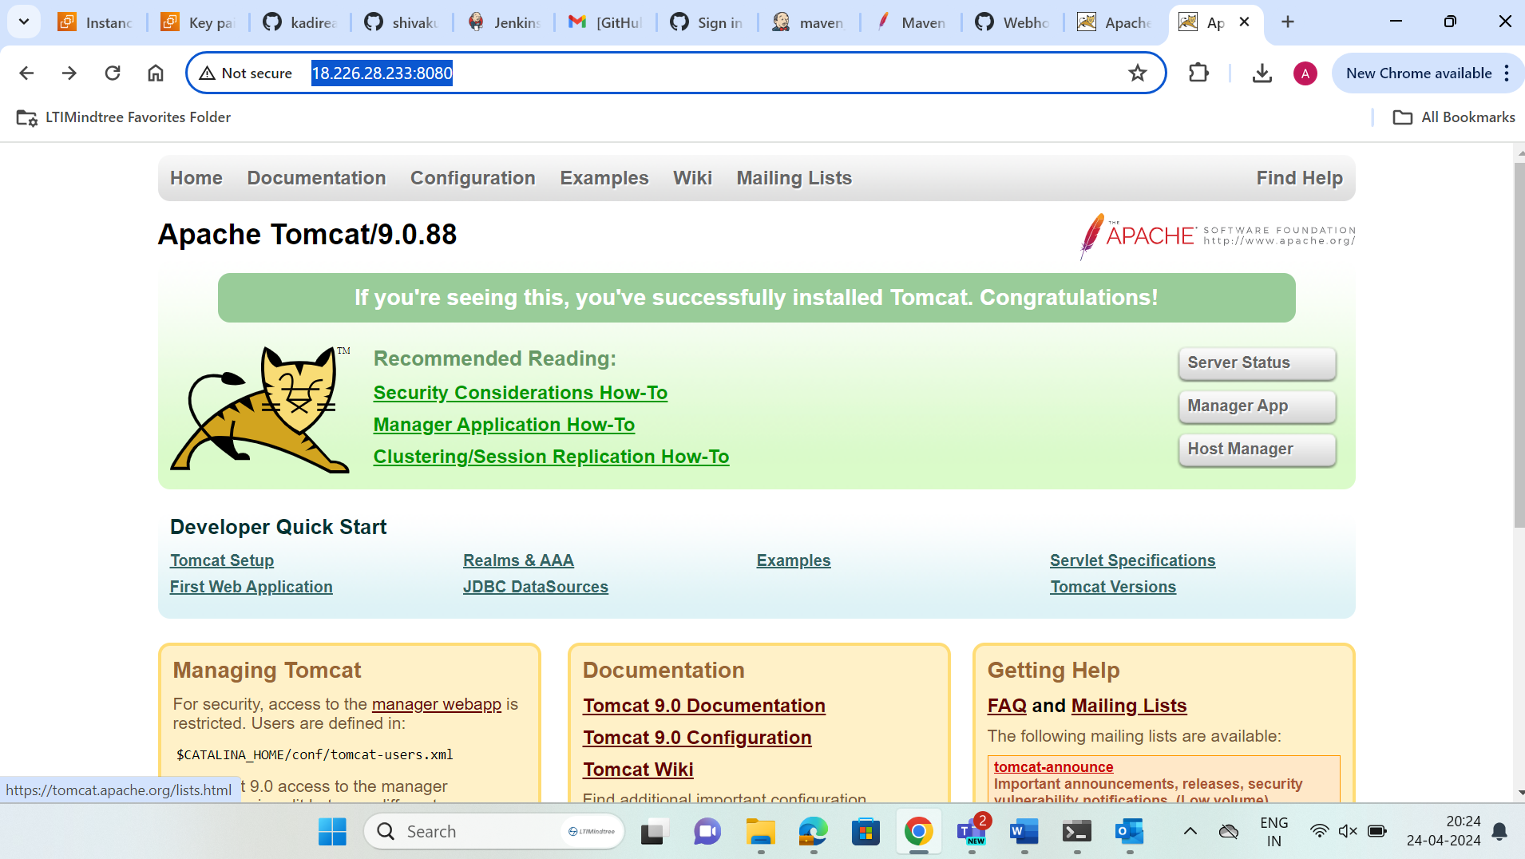

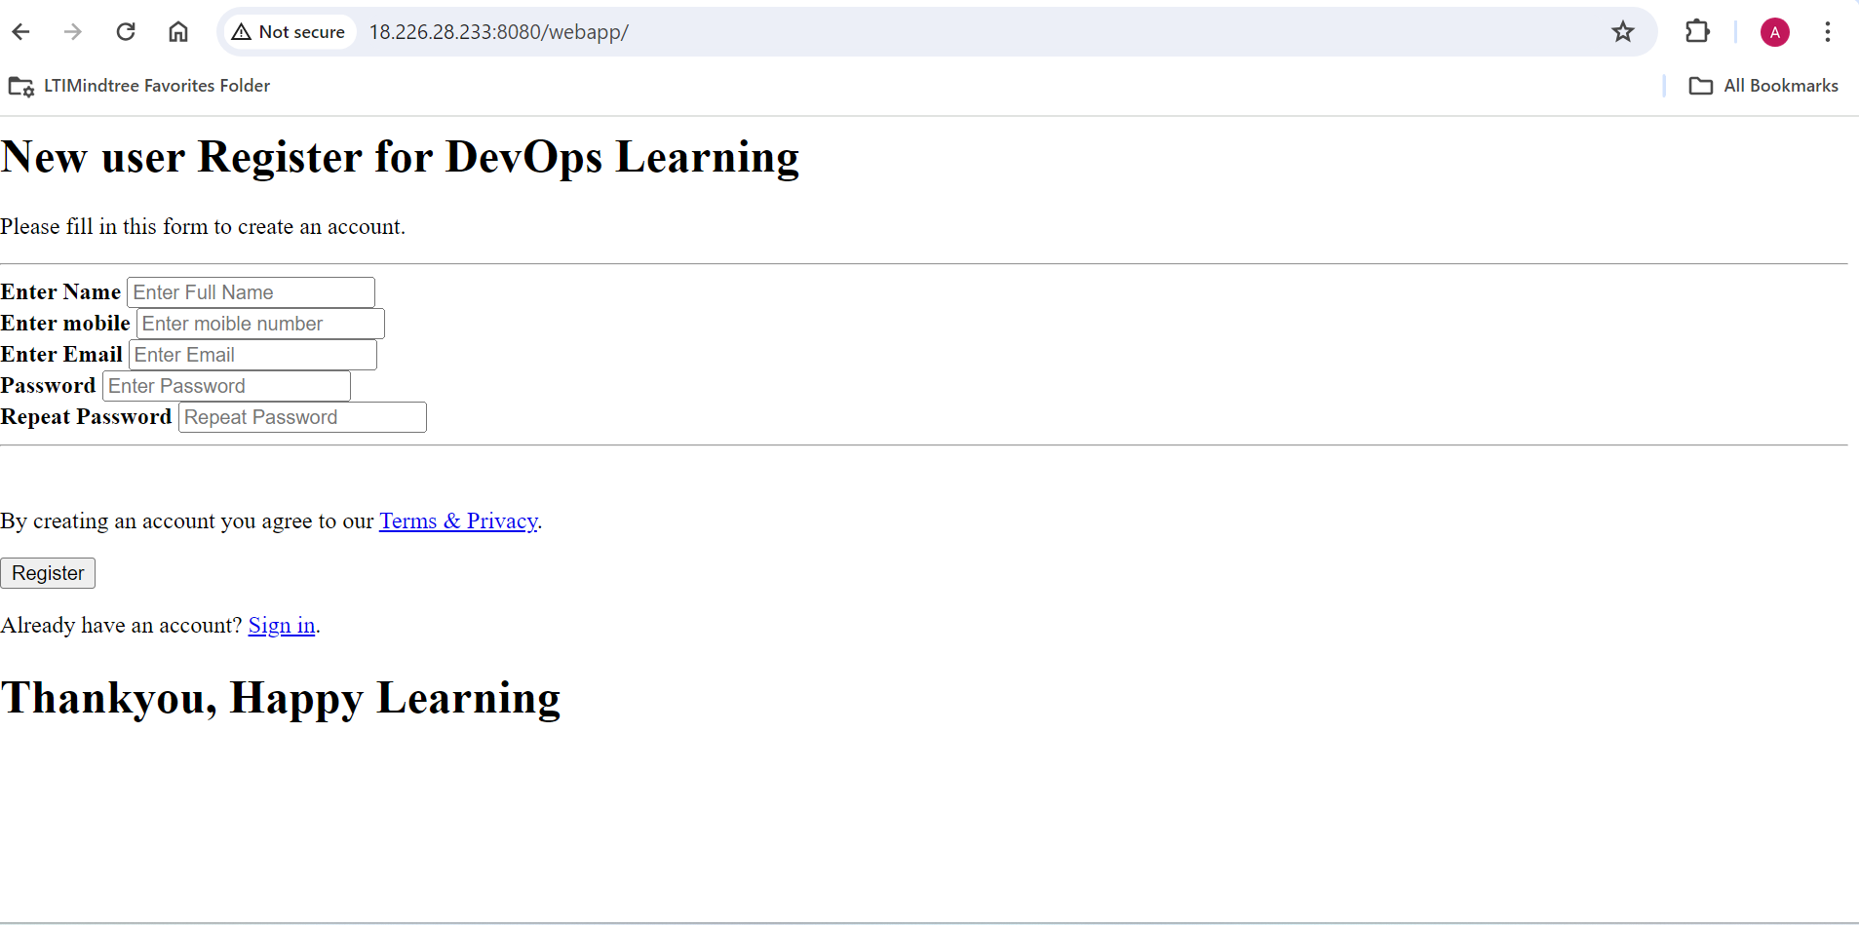

🡪Now after this we need to launch ansible server and create user and give all the permissions of root .Install ansible and configure system using publish over SSH.

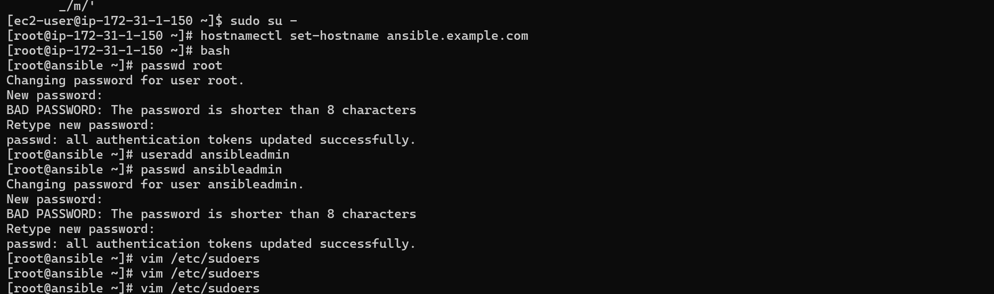

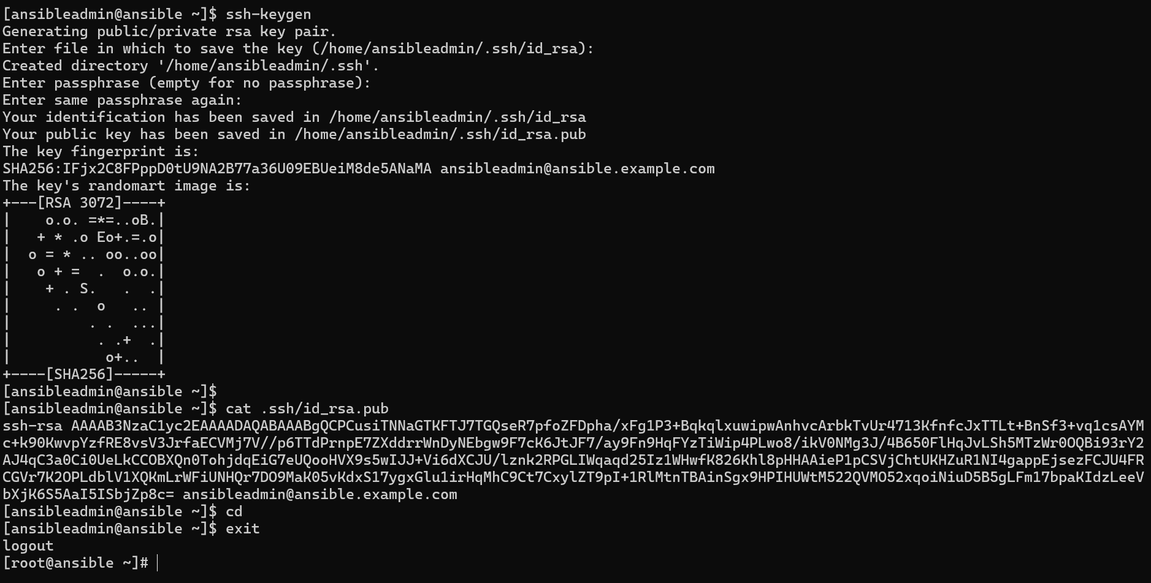

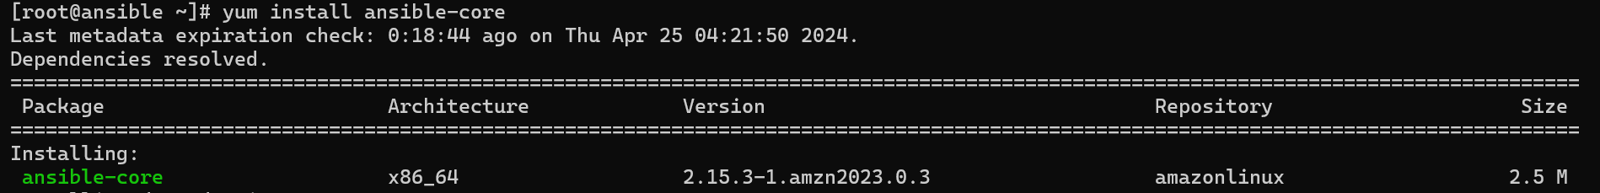

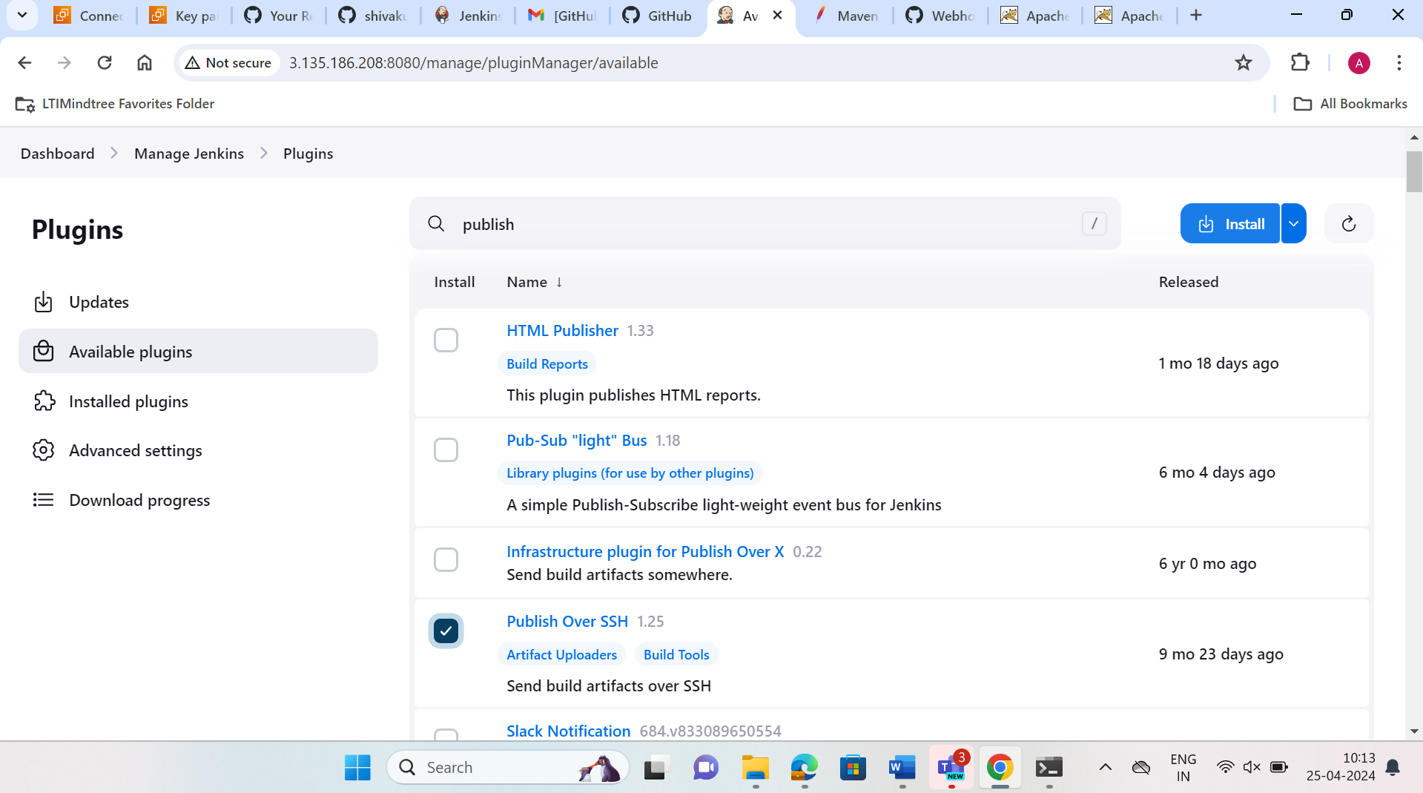

🡪By giving the password of the user and the private ip of the ansible server the config is success.

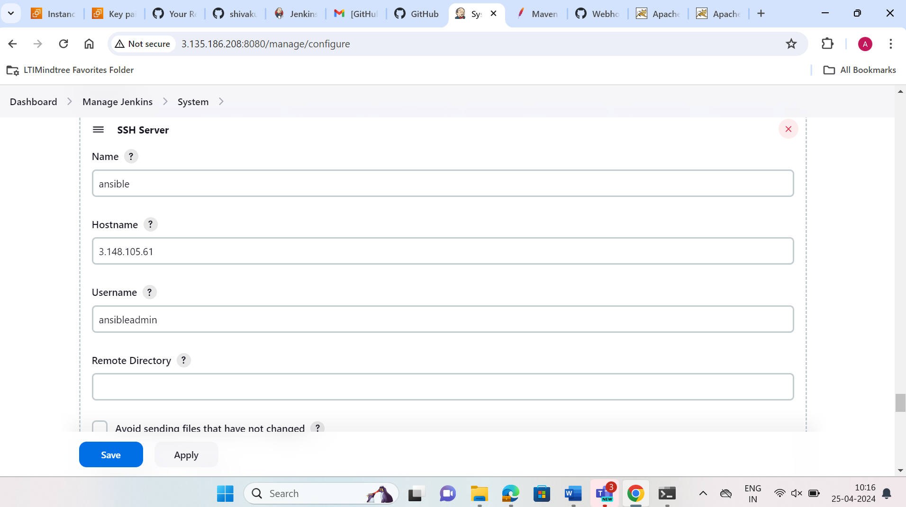

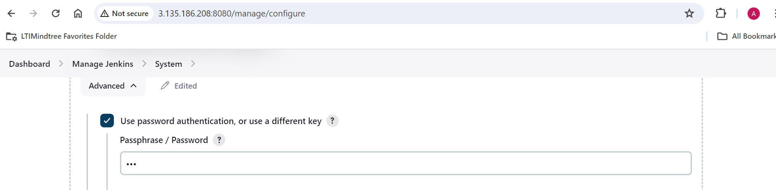

🡪Now after that we need to go to the /opt directory and install the docker there.After that we need to create a docker file to create image.

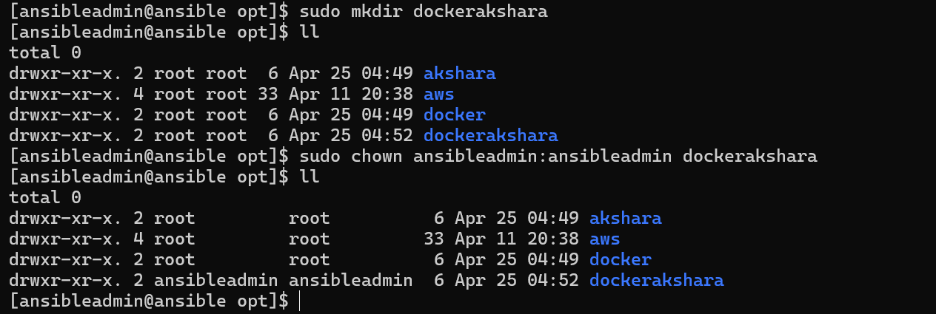

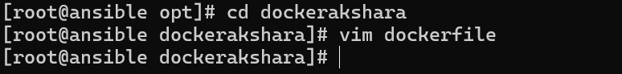

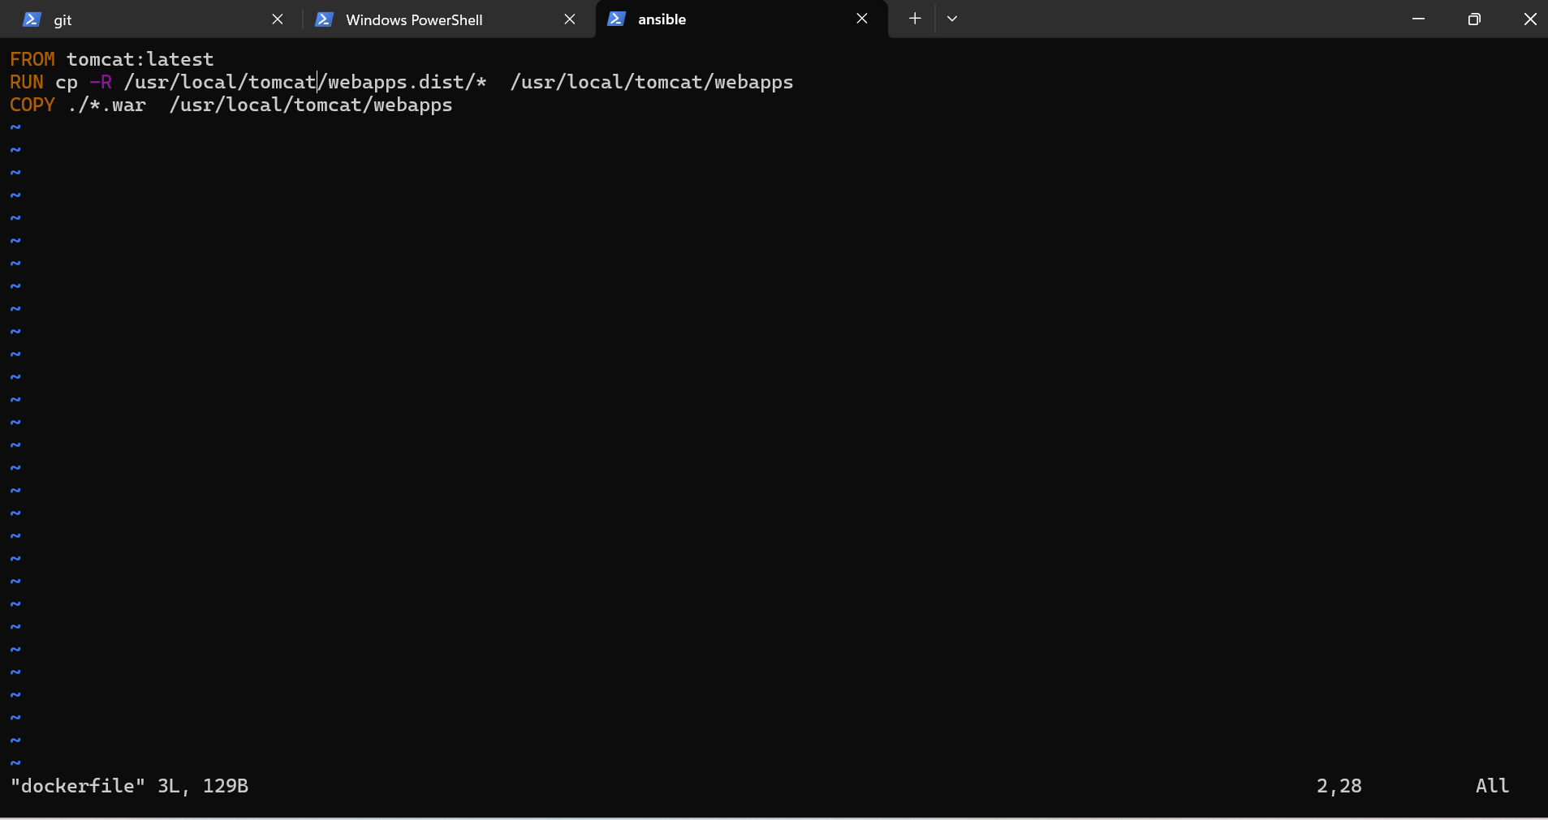

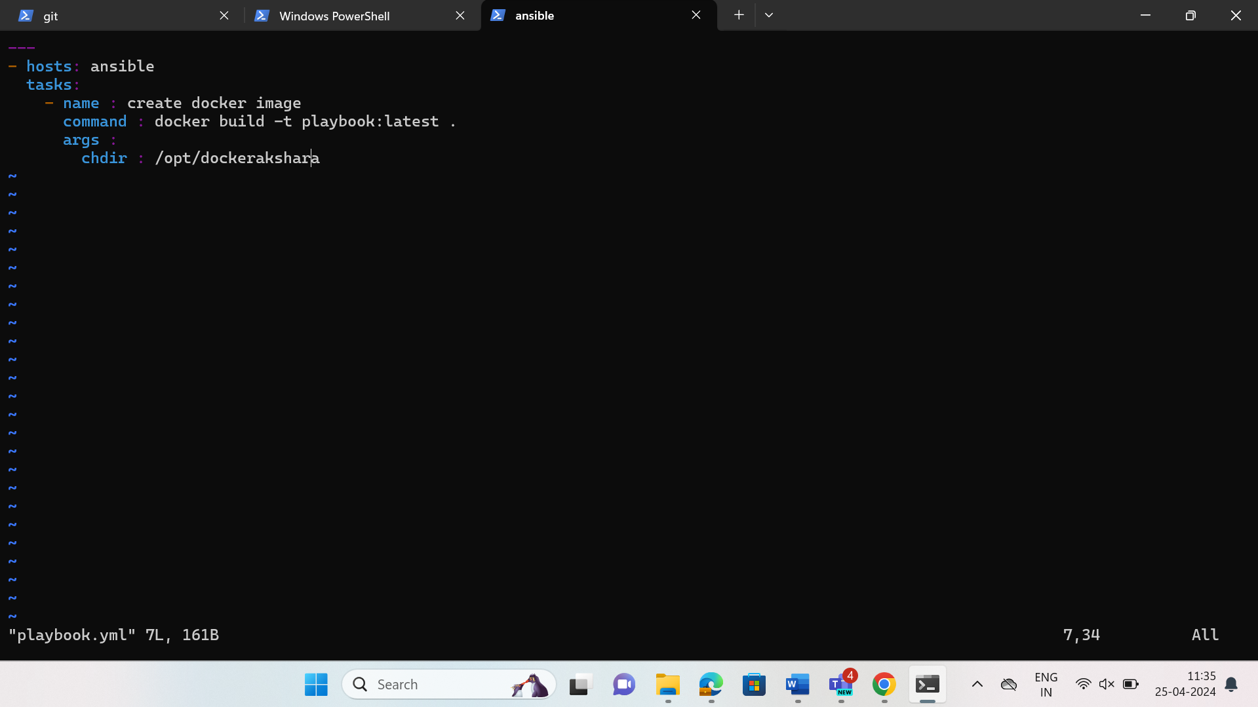

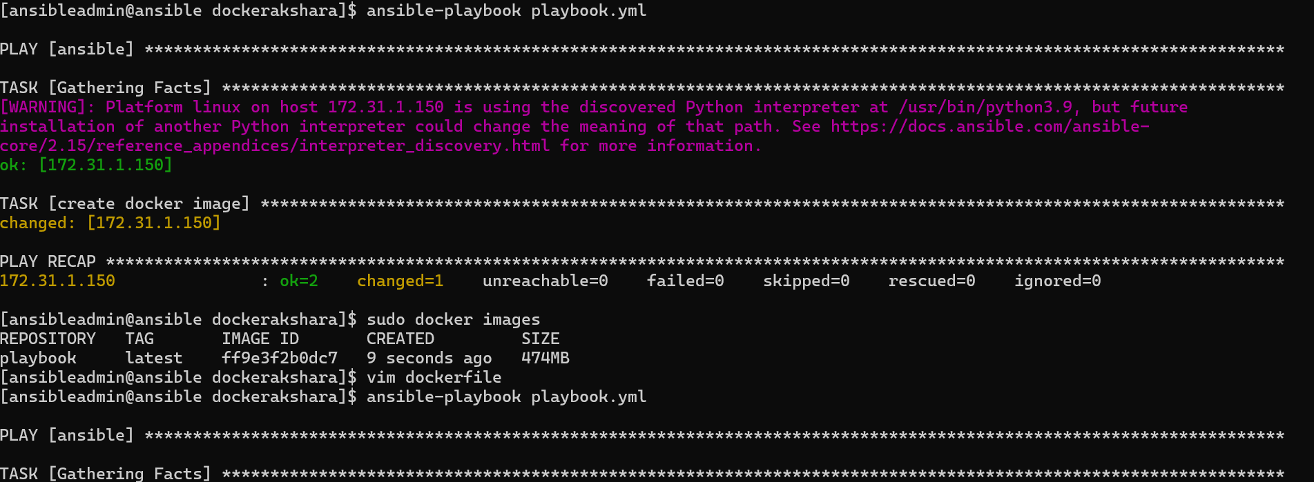

🡪After that we need to copy artifacts to ansible as shown below.

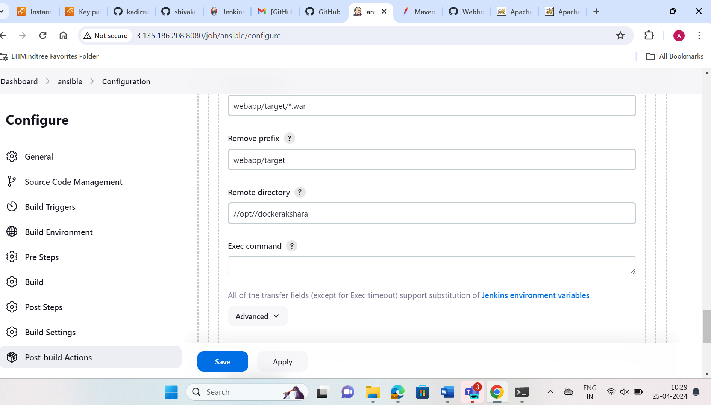

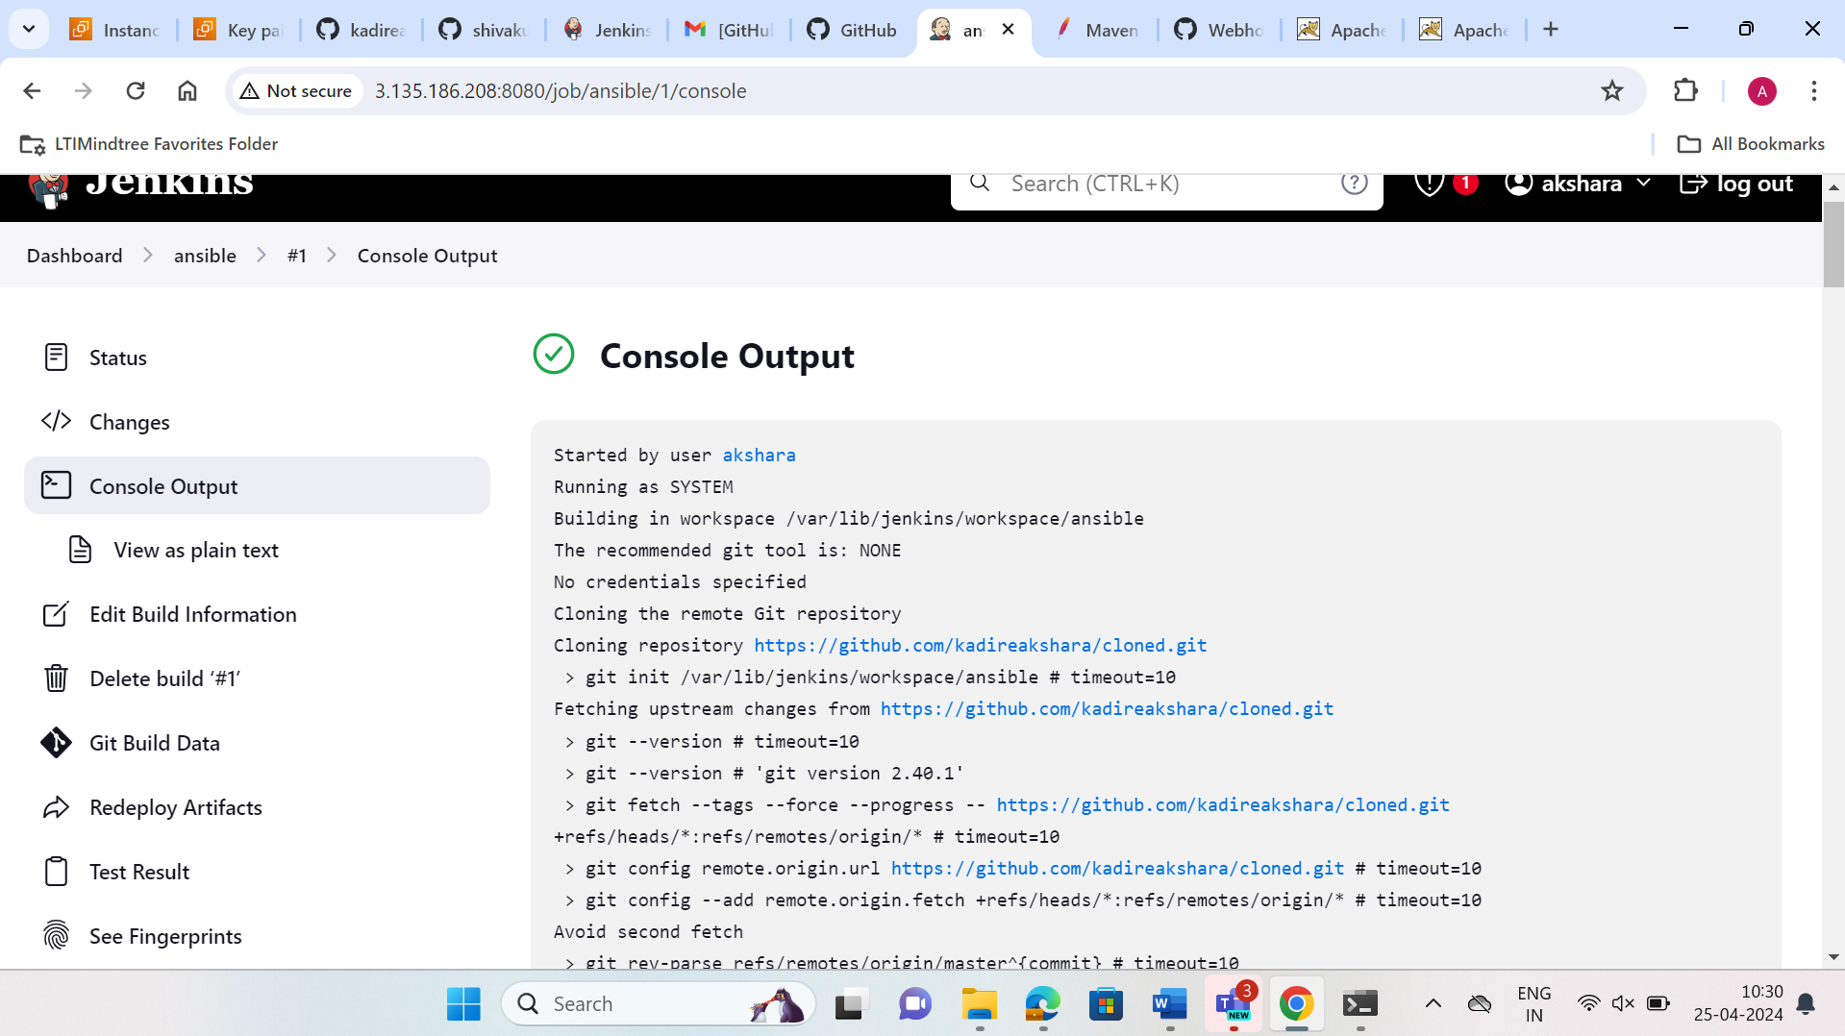

🡪Now we will get the war file into the docker directory.By this the responsibilty of ansible is done here.We need to add group in the hosts file by giving the ip address of the ansible.

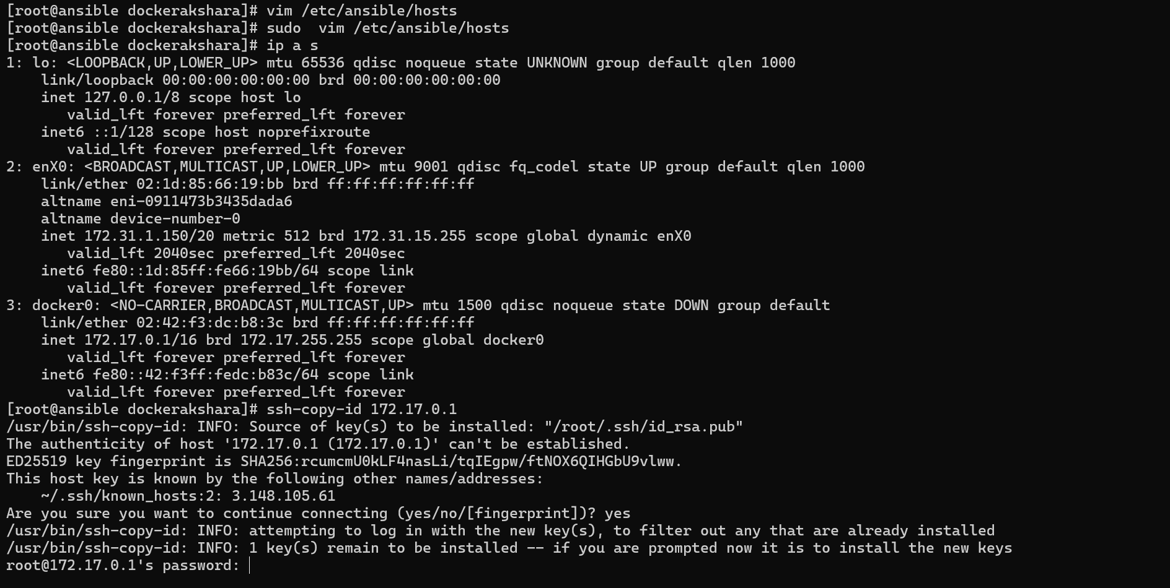

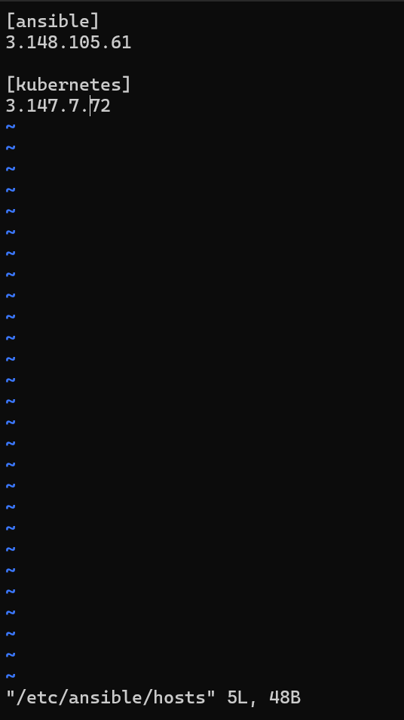

->Now create a playbook which creates the docker image and write the below code as shown and run.



🡪Now after running docker image will be created.Now we use the ECR service from AWS for pushing the image into the container repository.Go to the

ECR -> create repository -> public -> select the system and configuration -> create.

A repository will be created.We need to congifure the aws cli and also create a user with ECR full access policy attached.Create access key and secret key for the user and configure aws cli by giving the credentials and region.

🡪Now go to the container repository and use the commands used for pushing the image as given.

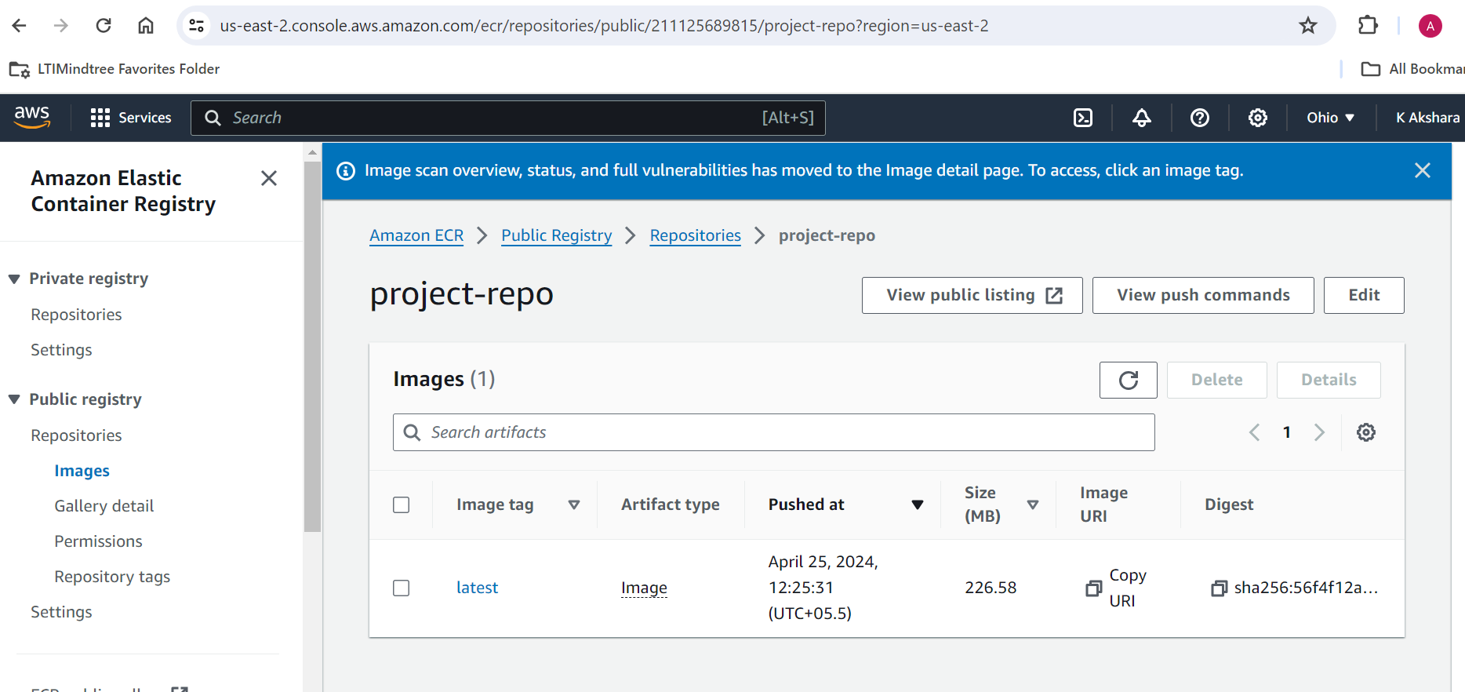

🡪After doing the commands we can observer that a image with the tag latest is pushed into the container repository.

**Setup bootstrap server for eksctl:**

🡪Now after this we need to setup kubernetes i.e eksctl.Launch a eksctl instance and install kubectl and eksctl. Make sure they are in the bin directory.

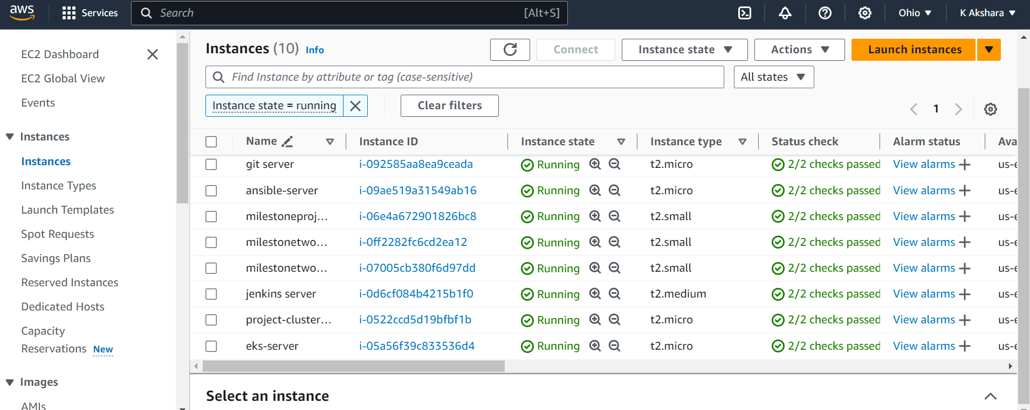

🡪In the eksctl we need to enable the password based authentication.

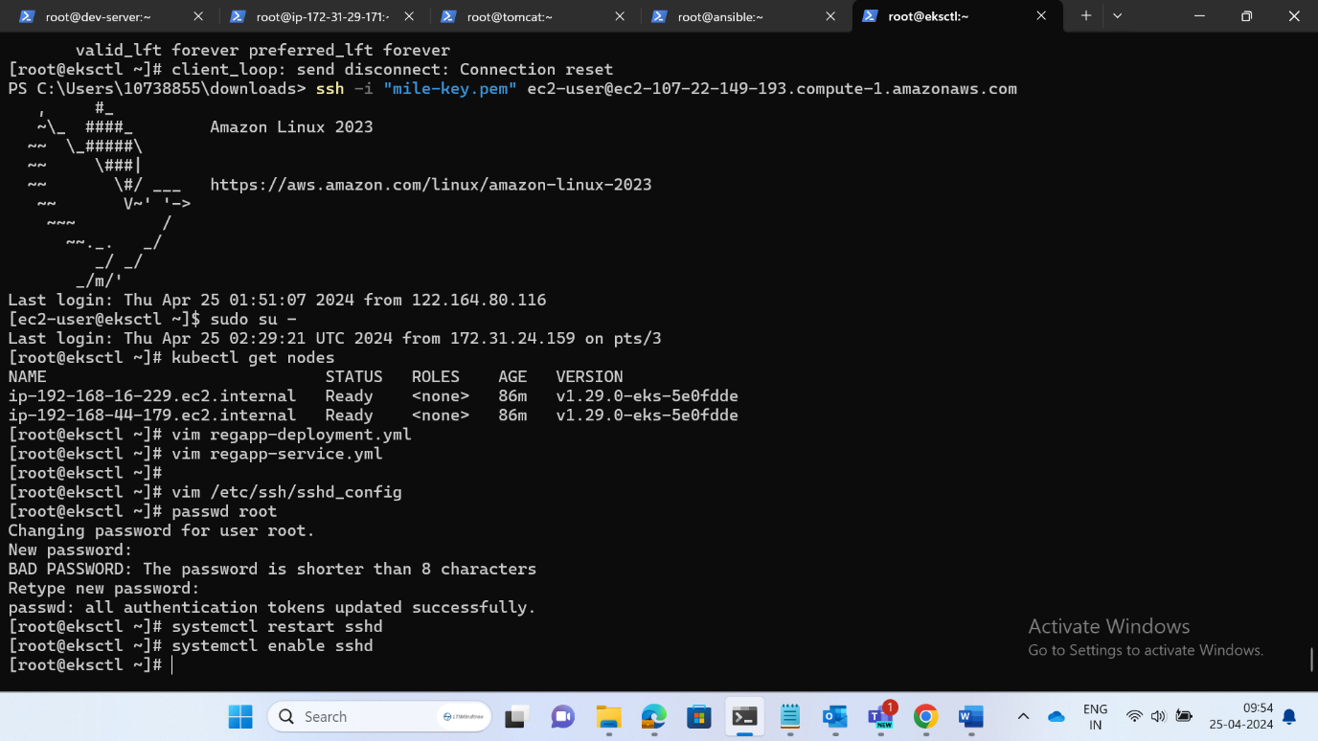

🡪Create an IAM role with the following permissions as shown below and attach to the eksctl instance so that we can create cluster accordingly.

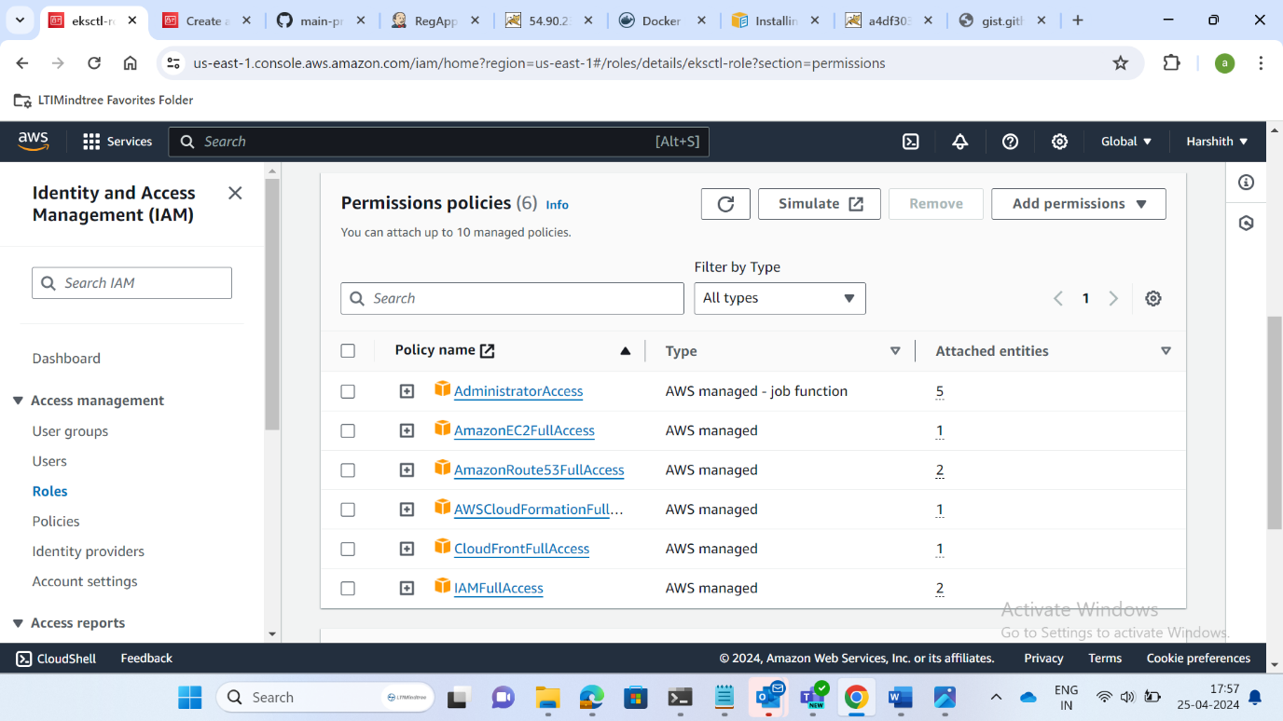

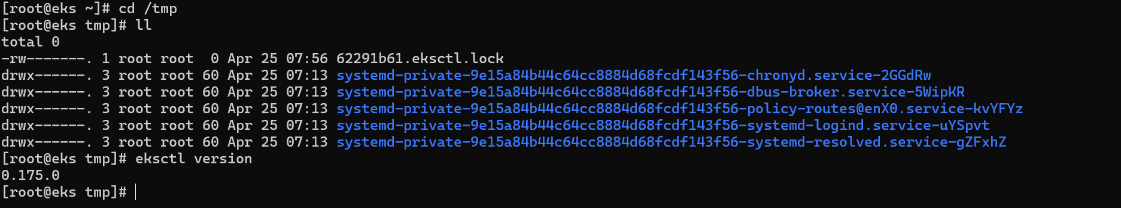

🡪Now create cluster by giving the command eksctl create cluster and specify the region and node type.



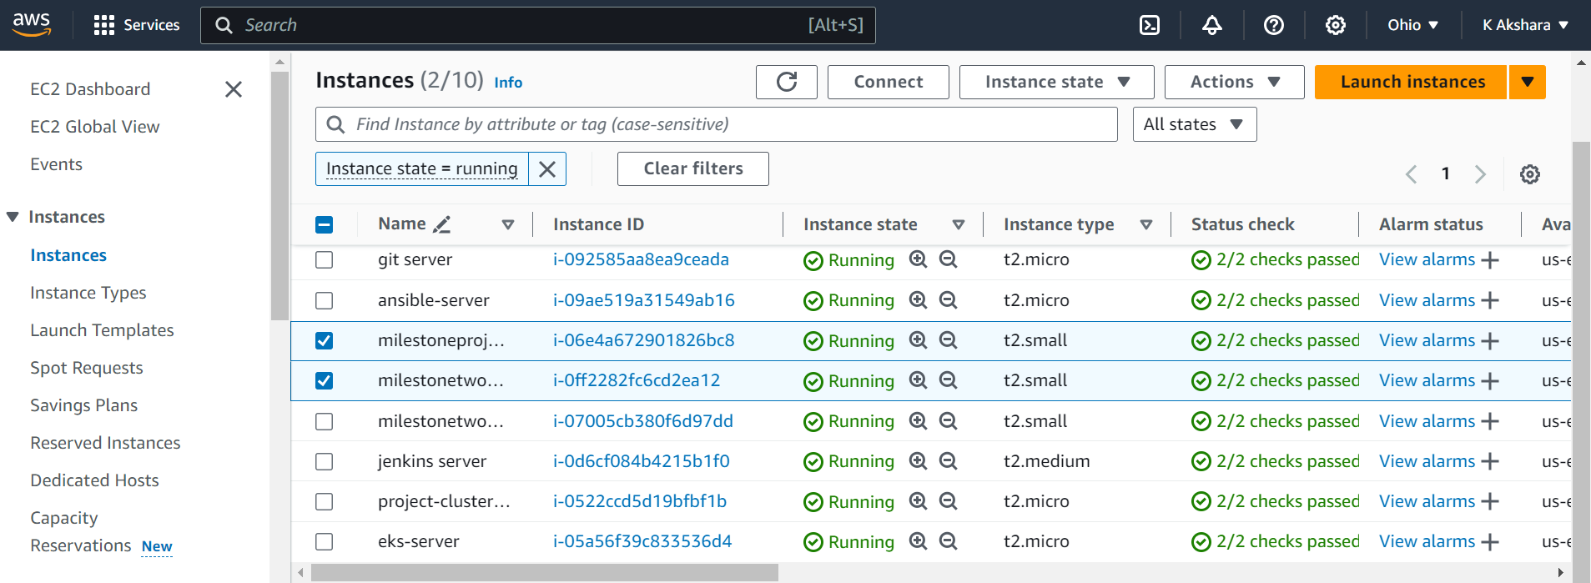

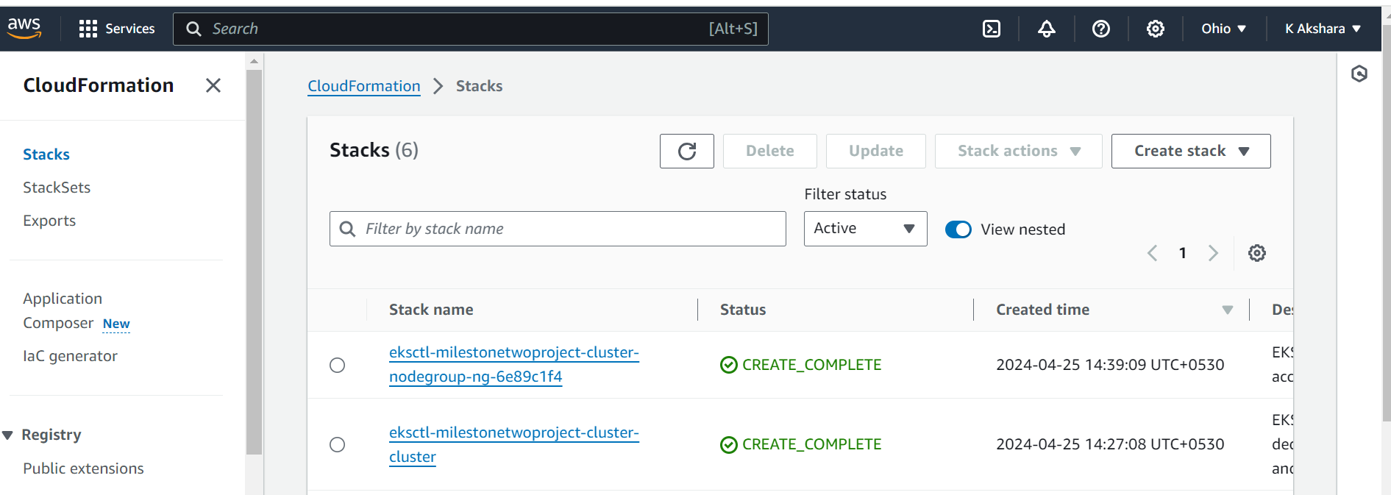

🡪Now we can observe that the cluster is created.We need to create a manifest file as shown below. One is for the deployment and other is for the service.In the service we use load-balancer as it is the best service when compared to other services.

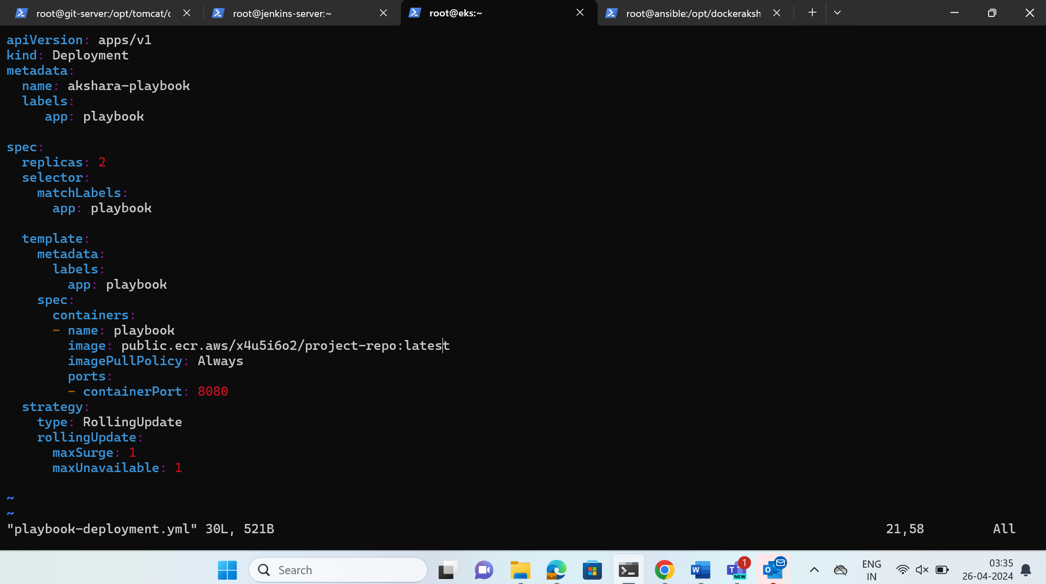

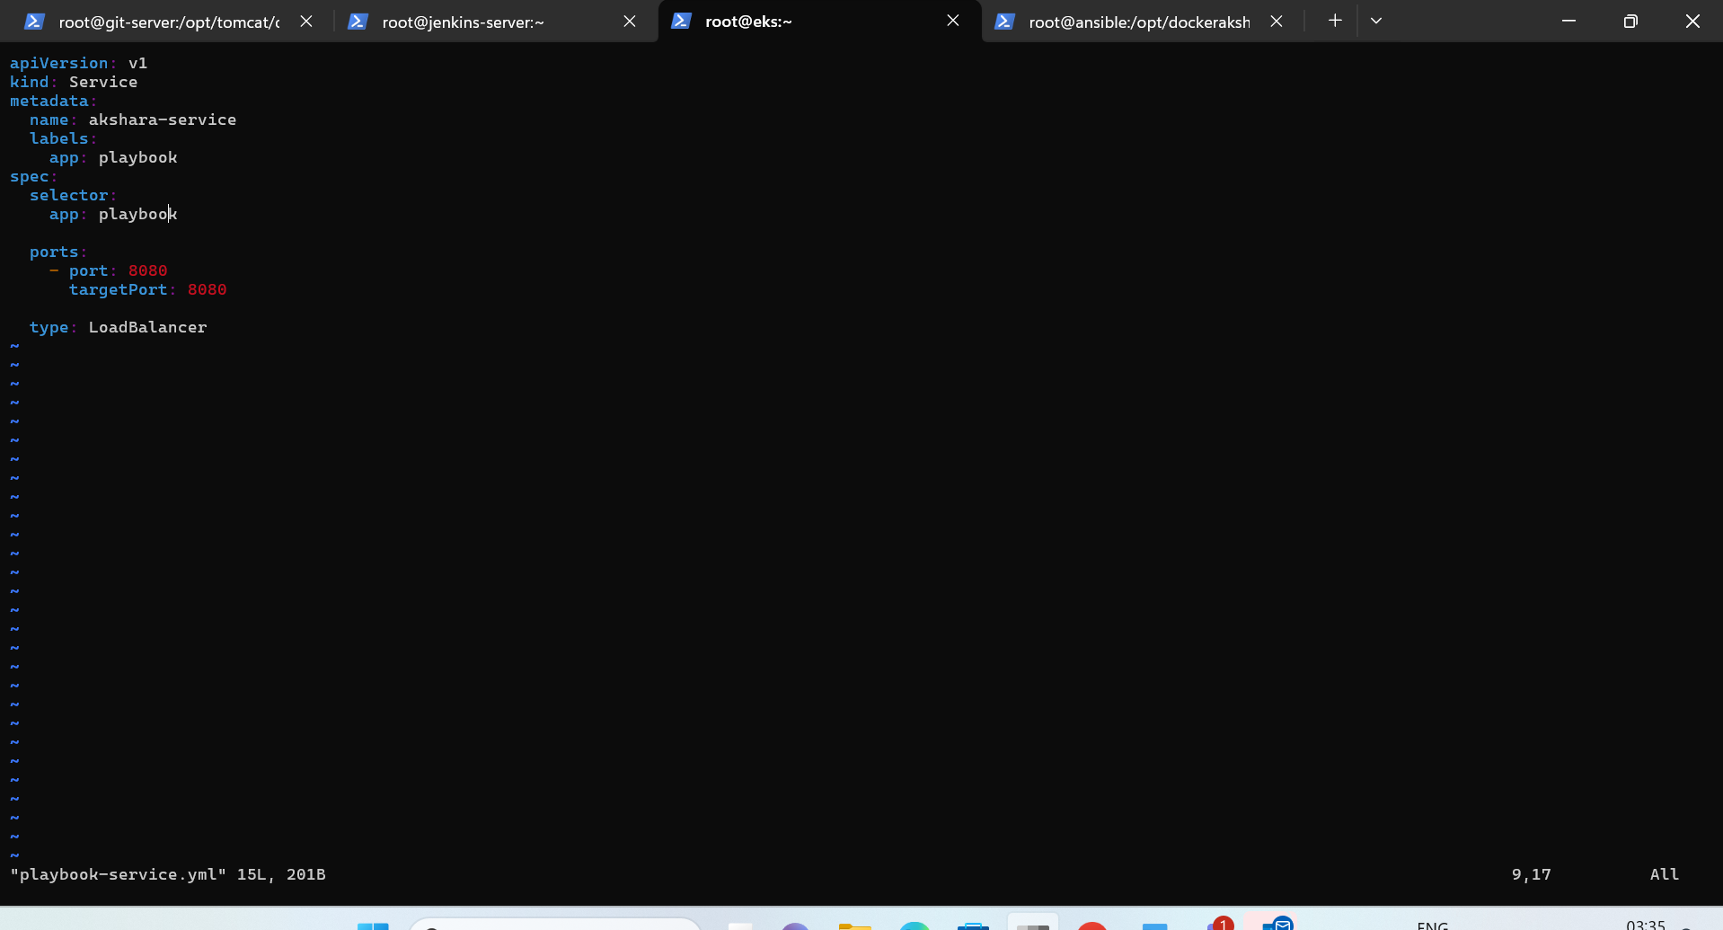

🡪Now run kubectl apply for the service then the service will be created.In the same way for the deployment,we can check the output i.e pods,deployment,service by using the kubectl get all.

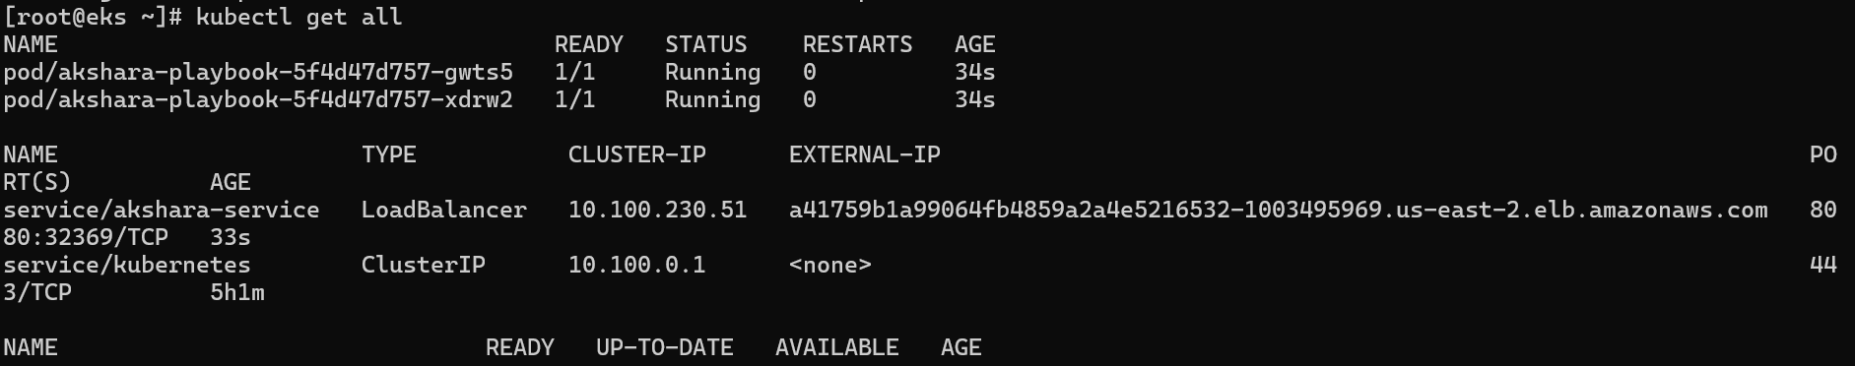

->After that we need to integrate bootstrap(eks) server with the ansible.So that we need to add the user into sudoers and then we need to copy the SSH key to the authorized_keys so that we can integrate into eksctl from ansible accordingly.We need to deploy the eksctl with ansible so that we will create one ansible playbook.

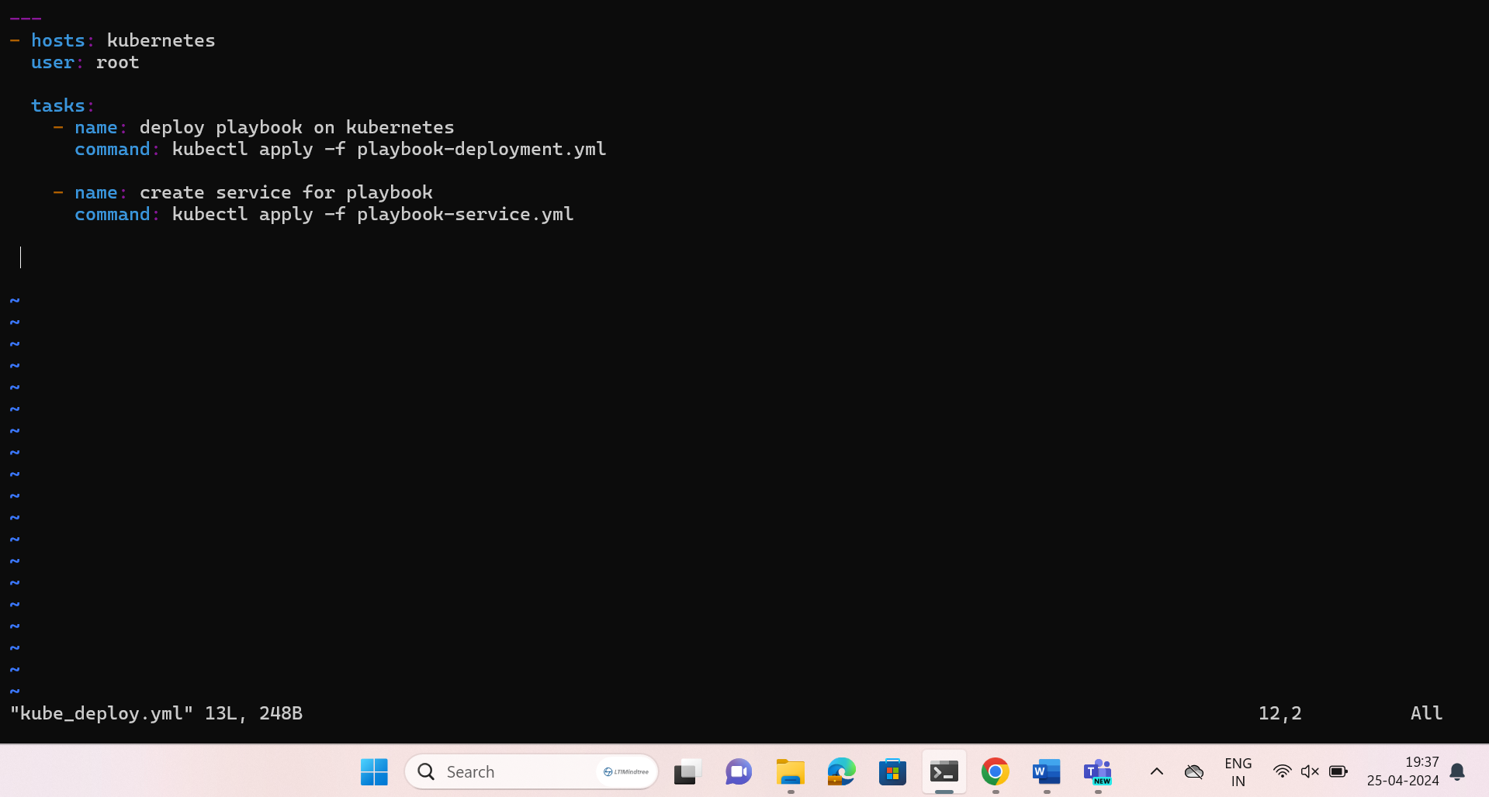

🡪Now run the ansible book as shown below.

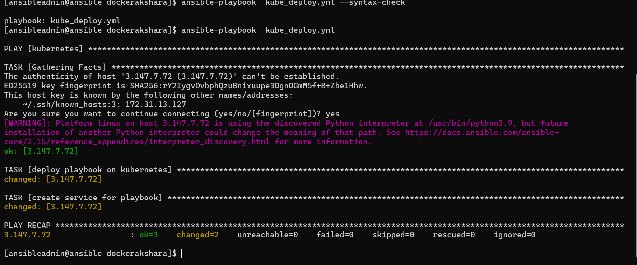

🡪Here we should create jenkins deployment job kubernetes.Go to the CI in the jenkins and give the git repo link.Give the branch specifier and in the triggers give poll scm as it should runned when ever commit is done to the repository.In the goal and options we need to give clean install to execute.Select the post step as run regardless of built.Specify the build other projects (CD) and select trigger only if build is stable.Add post build action as send build artifacts over SSH.Here give the server name and EXEC command then apply and save.

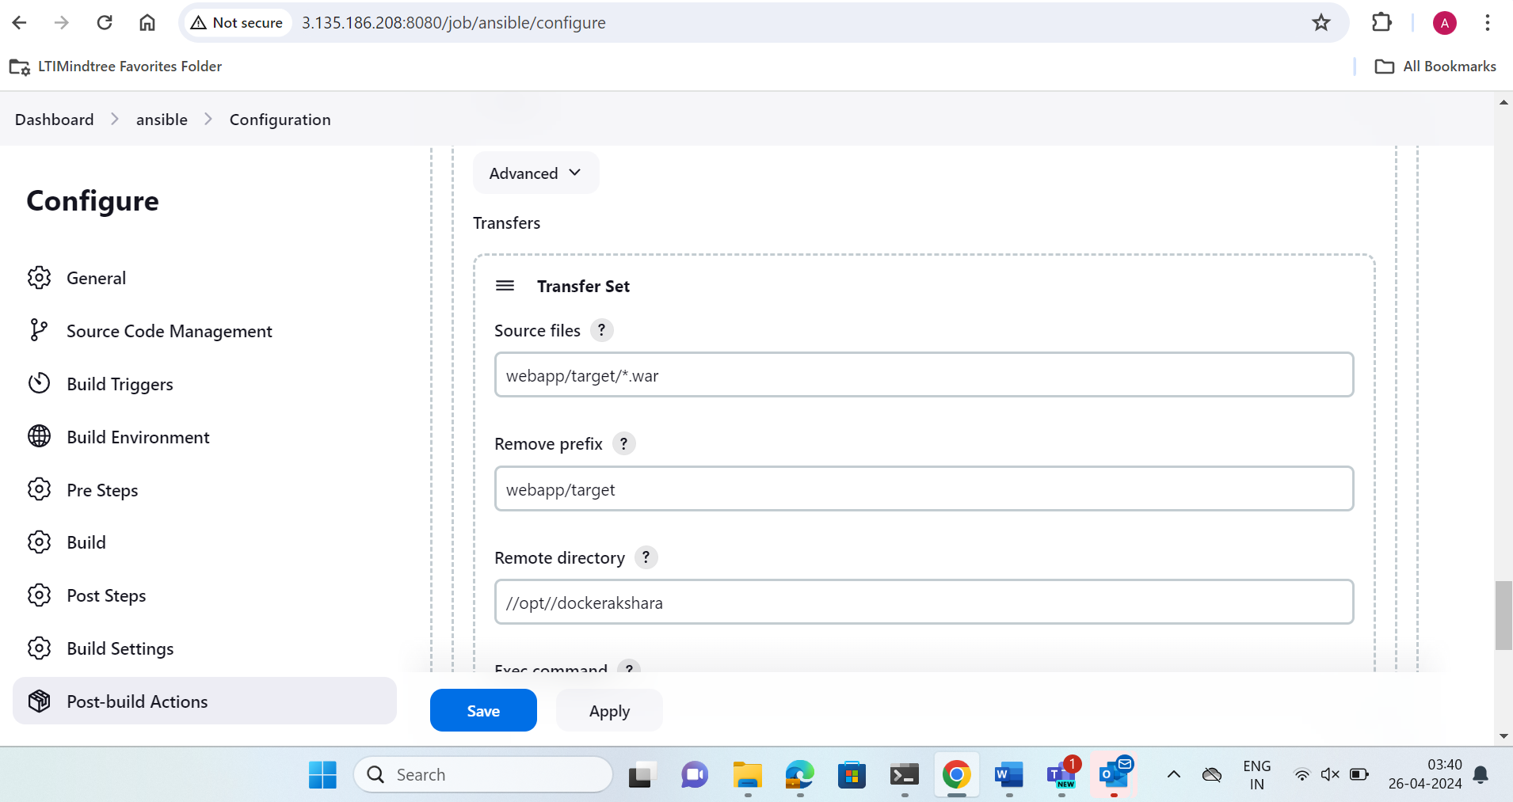

🡪After that go to the eksctl bootstrap server and give command like kubectl get all,we will get all the pods,services,deployments and replicas.Now in the service table copy the load-balancer external IP and paste in the new window.We can observe that the changes are reflected automatically in the application also.



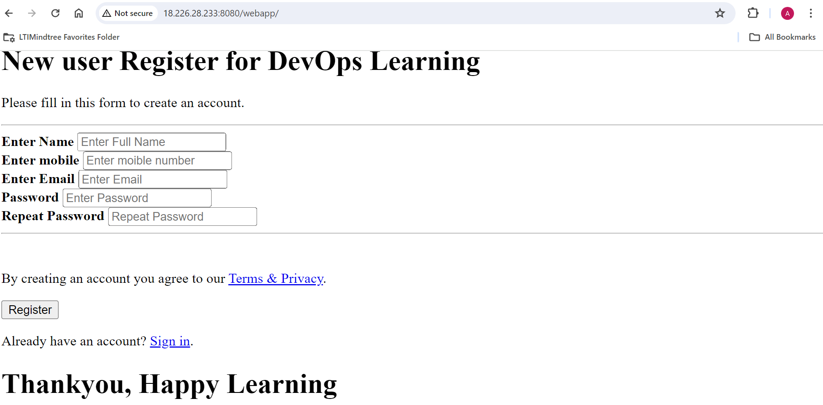

🡪The above is the approach proposed for the creation of end-to-end CI/CD pipeline in aws platform using the devops tools like Github, jenkins,ansible,docker,kubernetes and maven for web application.

